Nottingham Trent University

School of Science and Technology

**Q: Can small-scale movements & low volume noises, allow a parent to get a prediction for an infants need for food.**

by

Richard Magnus-George

in

2016

Project report in part fulfilment

of the requirements for the degree of

Bachelor of Science with Honours

in

Computer System Engineering

I hereby declare that I am the sole author of this report. I authorise the Nottingham Trent University to lend this report to other institutions or individuals for the purpose of scholarly research.

I also authorize the Nottingham Trent University to reproduce this report by photocopying or by other means, in total or in part, at the request of other institutions or individuals for the purpose of scholarly research.

Signature

Richard Magnus-George

Abstract

The project aims to produce a modern solution to predict hunger in infants based on Pricilla Dunstan’s theory. The purpose of this is to help simplify the job of infant baby parenting and to possibly decrease chances of behavior disorder development in infants.

This will be done by using a combination of various sensors to detect and record specific levels of noises and movements from the infant to capture certain signs that could indicate hunger.

Considering the number of people who own a smart phone increases yearly, a mobile notification system including possible suggestions will be used to inform parents/carers.

Acknowledgements

First and foremost I would like to thank GOD for giving me the strength and guidance to tackle any situation presented to me and showing me a way when I could not see the light at the end of the tunnel.

I would also like to thank the two greatest women in my life, my Mother Doris Obeng, for being my hero and greatest support through my highs and lows of this amazing journey and my Grandmother Mary Sackey, for giving me the motivation to excel and strive for greatness. Your memory will forever remain in my heart.

I would like to also show my appreciation to my project supervisor, Dr Evtim Peytchev, for his guidance and support for my final year project.

Finally, I would like to thank my lecturer Dr Jon Robinson, for providing me assistant during his spare time, as his expertise helped me to tackle various obstacles.

Table of Contents

Abstract ii

Acknowledgements iii

Table of Contents iv

List of Figures ix

List of Tables x

CHAPTER 1 1

Introduction 1

1.1 Introduction 1

CHAPTER 2 5

CONTEXT 5

2.1 Introduction 5

2.1.1 Infant Monitoring System 6

2.1.2 Current Infant care System Purpose 8

2.2 Problems associated with infants 9

2.2.1 Behaviour Disorder Development & Parent to Infant inheritance (domino affects) 9

2.2.2 Identifying an Infants Needs 10

2.3 Monitoring Systems 11

2.3.1 Traditional 11

2.3.2 Modern 13

2.4 Identifying signs and signals 16

2.4.1 Sound 16

2.4.2 Motion 19

2.5 Current Solutions 21

2.6 Summary 24

CHAPTER 3 26

New Ideas 26

3.1 Introduction 26

3.2 Proposed Idea 26

3.3 Proposed solution 28

3.3.1 Sensors and Hardware 28

3.3.2 Data Transfer 30

3.3.3 Processing Data 36

3.3.4 Notification 38

3.4 Functional & Non-Functional Requirements 43

3.4.1 Functional Requirements 43

3.4.2 Non-Functional Requirements 44

3.5 System Requirements 45

3.5.1 Hardware Requirements 45

3.5.2 Software Requirements 46

3.6 Architecture 47

3.6.1 Overview 47

3.6.2 Data from the Sensors 48

3.6.3 Server & Data Processing/Querying 49

3.7 Flow Chart 49

3.8 Project Plan 50

3.8.1 Gantt chart 50

3.8.2 Contingency Planning 51

3.9 Summary 52

CHAPTER 4 53

IMPLEMENTATION 53

4.1 Introduction 53

4.2 Methodology 53

4.3 Analyse baby cries 57

4.4 Programming environments 58

4.5 Connecting sound sensor to Arduino 59

4.6 Obtain frequency 60

4.6.1 Finding more accurate threshold 61

4.7 Serial Communication 62

4.8 Obtain motion 63

4.9 Setup conditions 67

4.10 Process Data 68

4.11 Setup notification 72

4.12 Manager 74

4.13 Summary 75

CHAPTER 5 77

RESULTS / DISCUSSION 77

5.1 Introduction 77

5.2 Testing 77

5.2.1 Testing environment 77

5.2.2 Black Box Testing 78

5.2.3 Further Testing 80

5.3 Discussion 86

5.4 Summary 87

CHAPTER 6 89

CONCLUSIONS / FUTURE WORK 89

6.1 Conclusion 89

6.2 Future work 89

6.2.1 Using the spatial 3/3/3 instead of 0/0/3 90

6.2.2 Use of Omni Microphone instead of directional 90

6.2.3 Video recognition software & connect sensor 91

6.2.4 Extracting all other sound apart from cries 92

6.2.5 Having sensors in one unit 92

6.2.6 Notification process 93

6.3 PSEL Issues 94

6.3.1 Professional 94

6.3.2 Social 94

6.3.3 Ethical 95

6.3.4 Legal 95

References 96

Bibliography 100

Appendix A – UML classes 105

Appendix b – Gantt charts 1

Appendix c – Project planning document 2

Appendix D – UML classes 13

List of Figures

Figure 1 (Radio Nurse) 12

Figure 2 (IControl Networks Piper) 15

Figure 3 (Early Hunger Clues) 20

Figure 4 (Late Hunger Clues) 20

Figure 5 (Sensor Unit) 22

Figure 7 (KODAK CFH-BVA10) 24

Figure 8 (Raspberry Pi) 34

Figure 9(Arduino) 35

Figure 10 (Infant Monitoring System Architecture) 47

Figure 11 (System Data Flow Diagram) 50

Figure 12 (Audacity plot spectrum frequency analysis tool) 58

Figure 13 (Arduino Electrical Engineering set up) 59

Figure 14 (Arduino & Sensor set up guide) 60

Figure 15 (Arduino IDE code) 61

Figure 16 (Arduino IDE Serial port listener, listening to cry frequencies) 62

Figure 17 (Spatial Phidget sensor threshold test) 63

Figure 21 (Spatial Phidget 0/0/3 Code4 (Detach)) 66

Figure 23 (Read Conditions code) 67

Figure 24 (Condition body code) 68

Figure 25 (Sound Condition checking process) 70

Figure 26 (Motion Condition checking process) 71

Figure 27 (Suggestion class) 71

Figure 28 (Data Processing Test) 72

Figure 29 (Notification method & Suggestion call) 73

Figure 30 (Test Email) 74

Figure 31 (Manager class) 75

List of Tables

Table 1 (Sensors and Conditions) 48

Table 2 (Development Environments for various tasks) 59

Table 3 (Black Box Test Plan) 79

Table 4 (Averaged Spatial Accelerometer Test Results) 81

Table 5 (Spatial Accelerometer Condition Test Results) 82

Table 6 (Microphone Sensor Condition Test Results) 83

Table 7 (Overall System Test Results (Pre-Cries)) 84

Table 8 (Overall System Test Results (Active-Cries)) 85

Table 9 (Overall System Test Results (Late-Cries)) 86

Table 10 (Arduino Micro Controllers) 13



Introduction

Introduction

Caring for new-born infants holds a reputation of being one of the most challenging jobs life can offer. Many carers have stressed and suffered overcoming this challenge, especially first time parents/carers.

Since the 1930’s many solutions where invented to help aid in this task, giving carers a sense of security for their infants and simplifying the job of caring for new-borns (vam.ac.uk, 2016).

Since the 1930’s technology has dramatically evolved opening up new doors for opportunities. Various modern technologies have been opted and integrated into the world of infant caring, by enhancing and upgrading infant monitor systems giving carers more tools to take care of their infants.

However, many doctors like, Dr. Richard Wilson strongly believes that “there is no known gadget or device that will prevent cot death” (news.bbc.co.uk, 1999) also known as SIDS (Sudden Infant Death Syndrome) as most of these current solutions are monitoring systems and are not built to prevent.

Due to the growth of information available in the world of infants, new issues stemming from infant caring have arisen but have also concurrently revealed leads of how to possibly prevent some of these issues from happening.

As new-born infants cannot articulate communication with their carer to express their needs, current research of identifying infant’s needs has presented a spark of innovation and presented a path of investigation on whether small-scale sound and movements from an infant can lead to predictions of hunger.

The end goal of this project is to try and provide a systematic solution to target and prevent some of the existing issues within infant caring by making use of related infant theories, sensors and other existing technologies.

This project will be subdivided into several stages completed in a linier structure to ensure high quality and achieve success. The projects structure follows as, Introduction, Context, New Ideas, Implementation/Investigation, Results/Discussion and Conclusion/Future Work.

**Introduction** – This chapter is an overview of what the project is about and what issues are to be resolved. It also includes a brief overview of what the solutions are for tackling these issues and what will be involved in the research and implementation to make this possible.

**Context** – This chapter covers the research conducted to see what the current issues are and what solutions have been created or attempted. It covers the actual current issues to be focused on in depth. It also sheds light on what solutions are currently available, what their purposes are, why they have floors and where there is a gap for improvement.

**New** **Ideas** – This chapter reflects on the chapter prior to this. It presents new ideas using current existing technologies and technologies discussed in the previous chapter, to produce a design of a systematic solutions to tackle the current issues at hand to be implemented in the next chapter.

**Implementation**/**Investigation** – This chapter breaks the system down into sub-parts and goes into depth of each component implementation of the intended system design created in the previous chapter. The chapter also discusses the issues and obstacles that were posed on the way and elaborates on how they were tackled.

**Results**/**Discussion** - The chapter also reflects on previous chapters, as it compares the end product against the requirements that were set in chapter 3. It also includes various undertaken test to see if the results produced where what was to be expected and if not providing detailed results and analysis on why.

**Conclusion**/**Future** **Work** – The last chapter of the project is used to conclude on how much of a success the system and the project as a whole was. It also highlights the systems potential and any further improvements that could be made/modified for future work.



CONTEXT

## Introduction

The investigation of early indication for an infants need for hunger has revealed a gap for improvement in infant parenting. The approach taken in this investigation will be by constantly monitoring particular sounds and motions of infants between the ages of 0-3 months in their resting environment.

This investigation can help make infant baby parenting easier by giving the carer the opportunity to be notified of early identification of an infant’s hunger before receiving late indications (crying) and possibly decreasing the chances of behaviour disorder development later in the infant’s life.

The proposed solution will notify the carer of hunger needs when the infant is in their resting environment via their smart device (mobile) or any device around them with email capabilities, eliminating the need of extra receiver units.

Different notifications will be presented to the carer depending on what category of conditions are met when the results of the sensors have been picked up and queried against the conditions thresholds by the server.

This chapter’s purpose is to analyse and identify existing research in the different areas of infant parenting and monitor the gaps and unaddressed problems to ultimately provide a systematic solution to aid infant parenting.

The end goal is to design and implement a system that can identify early signals of hunger from infants using relatively cheap technology.

In addition to this, a key purpose of this chapter is to be able to identify a realistic achievable project scope for the intended system solution, as some functionality and capability of the intended system may not be achievable by the given deadline.

### Infant Monitoring System

The investigation of early indication for an infants need for hunger has revealed a gap for improvement in infant parenting. The approach taken in this investigation will be by constantly monitoring particular sounds and motions of infants between the ages of 0-3 months in their resting environment.

This investigation can help make infant baby parenting easier by giving the carer the opportunity to be notified of early identification of an infant’s hunger before receiving late indications (crying) and possibly decreasing the chances of behaviour disorder development later in the infant’s life.

The proposed solution will notify the carer of hunger needs when the infant is in their resting environment via their smart device (mobile) or any device around them with email capabilities, eliminating the need of extra receiver units.

Different notifications will be presented to the carer depending on what category of conditions are met when the results of the sensors have been picked up and queried against the conditions thresholds by the server.

This chapter’s purpose is to analyse and identify existing research in the different areas of infant parenting and monitor the gaps and unaddressed problems to ultimately provide a systematic solution to aid infant parenting.

The end goal is to design and implement a system that can identify early signals of hunger from infants using relatively cheap technology.

In addition to this, a key purpose of this chapter is to be able to identify a realistic achievable project scope for the intended system solution, as some functionality and capability of the intended system may not be achievable by the given deadline.

### Current Infant care System Purpose

Generally, the main purposes of infant monitoring systems have been to monitor and be alerted of any activity happening when your infant is in their resting area, which can give carers a sense of assurance and a peace of mind.

Additionally, some of the advanced infant monitoring systems has the ability of sensory monitoring, allowing them to be able to detect and measure vital signs such as movements, temperature, breathing etc. These sensor monitors allow the carer to be notified of abnormal behaviour (babycentre.co.uk, 2014).

However, sensory monitors are generally marketed as a tool to protect new-borns against SIDS (Sudden Infant Death Syndrome), but no evidence has been found to say that these types of infant monitor systems will prevent SIDS (babycentre.co.uk, 2014).

Many doctors including David King support the belief that smart infant monitors and infant wearable’s provide a false sense of security (time.com, 2014).

Some infant monitoring systems do try to aid in issues of infant parenting, however most of them do not actually try to tackle any of these issues or prevent them from happening.

Although some fatalities like SIDS is an issue that can not simply be tackled as there is no specific cause that leads to it, other areas in infant parenting such as prediction of infants needs could be focused on to make carers’ jobs easier and give infants a greater possibility of a healthier life.

## Problems associated with infants

### Behaviour Disorder Development & Parent to Infant inheritance (domino affects)

Research has shown that babies that persistently cry and those that have sleeping and eating difficulties in their first year of life have a stronger chance of developing behaviour problems later on in life (nhs.uk, 2011).

Research by students from the University’s of Basel, Warwick and Bochum, using meta-analysis, have found that these common issues which are also classed as “regularity problems”, affect 20% of children who go on to develop behaviour disorders. This includes ADHD, aggressive behaviour and temper tantrums, which can directly affect their external environments, causing barriers of progression and internal problems such as depression and anxiety. (nhs.uk, 2011).

In conjunction with this, this research also states that there was numerous test conducted in different conditioned environments to give more accurate averaged results.

One of these conditions were to analyse infants with these regularity concerns who come from multi-problem families with poor parent-child interaction and are surrounded by carers suffering from depression and stress.

These results have proven to be the worst outcome of all the analysed conditions, showing a direct link of parents/carers emotions having a domino affect onto infants (nhs.uk, 2011).

### Identifying an Infants Needs

One of the main key issues that all infant carers, and especially first time infant carers, have is identifying their infant’s needs.

Not being able to identify or differentiate between infants needs especially when it comes to feeding difficulties usually results in excessive crying which can have implications on the infant’s behaviour later on in life (nhs.uk, 2011).

Identifying infants needs at an early stage can help develop a healthy parent to infant relationship and give you infant good health and energy to help them learn and grow well (babycentre.co.uk, 2014).

## Monitoring Systems

### Traditional

Traditionally infant monitors were radio systems which only had the capability of monitoring sound using a transmitter unit equipped with a microphone and a receiver unit equipped with a speaker which transmitted the sounds picked up by radio waves, which was a point to point type of connection (Vare and Ptacek, 2002).

**Example of a traditional infant monitoring System**

In 1937 a Japanese-American sculptor named Isamu Noguchi designed the first ever baby monitor for a major American radio corporation called Zenith (vam.ac.uk, 2016). They called it the “Radio Nurse”.

The invention of this product was inspired by the kidnapping of Charles Lindbergh’s 2-year-old son, which caused the president of Zenith to fear for his daughter’s safety (slate.com, 2013).

This first infant monitor consisted of the two general parts, the “Guardian ear” which were the transmitters equipped with a microphone and the “Guardian” which was the receiver equipped with the speaker. As it was designed in the 1930’s, a time of limited technology, both components neither had mobile capabilities as they had to be powered via power sockets using wires. This meant that this technology was only useful if both the carer and the infant were constantly in the location of the transmitter and receiver. It was not until the 1990’s that cordless technology was commercially introduced (Vare and Ptacek, 2002).

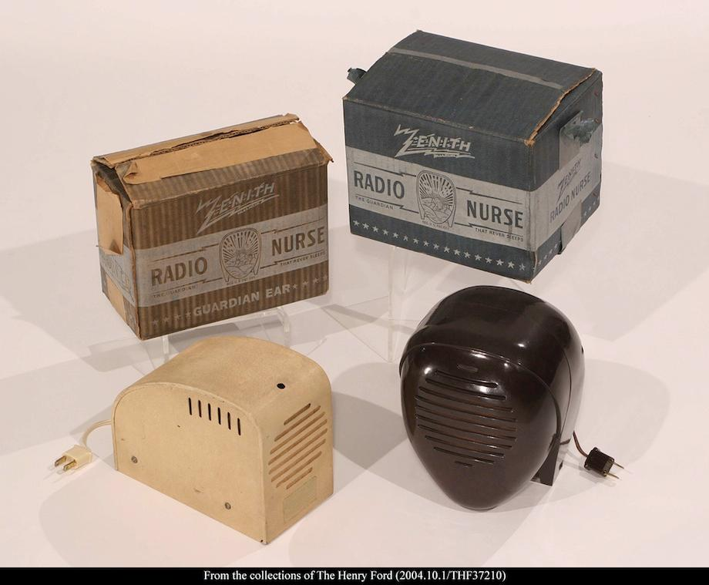

Figure (Radio Nurse)

### Modern

Nowadays as newer technologies are available, infant monitoring systems have evolved. Most modern infant monitoring system designs have made use of various technologies to add or enhance functionalities of infant monitor systems. Some of these technologies are listed below.

* **Real-time video web cams and visual monitors** – Webcams have been equipped onto transmitter units and visual monitor screens equipped onto receiver units to allow carers to have the ability to visually monitor their infant when they are not in visual distance, often referred to as “baby cams”. This was also further enhanced with HD (High-Definition) technology to have a high pixelated clear visual image displayed. In addition to this, night vision capabilities were also used to enhance this feature to give a visibly clear image from the transmitter even when the lighting conditions are poor.
* **Night/LED lights** – Transmitters units with coloured lights can be controlled from the receiver unit by the carer. This allows carers to remotely turn on and off or change the colour and shade of light in the infant’s environment.
* **WI-FI & 3G** – WI-FI and 3G capabilities have now been incorporated into these infant-monitoring systems opening a gate of usable functionality. This has allowed transmitters and receiver to have an established connection over their home LAN (Local Area Network). It has also opened a market for infant monitor mobile applications as the use of Internet introduces the BYOD (Bring Your Own Device) policy allowing carers to be able to use their own everyday smart devices as receiver units. In addition to this, it can provide unlimited reach of the infant monitoring systems, as some are 3G capable. Consequently, if the WI-FI signal is falling weak mobile data can be used instead which does not depend on distance from an access point so Internet can be utilised from most locations. Use of Internet also helps eliminate the idea of point-to-point connection giving the ability to have more than just one receiver to each transmitter.
* **Motion detection** – Motion detection sensors have also been utilised to increase surveillance and accuracy of activity. This type of technology is used in infant monitoring systems to generally notify carers when their infant has awakened from sleep or when there has been no active movement from the infant for a certain period of time.

These are just some examples of technologies that have been utilised in the field of infant monitoring.

**Example of a modern infant monitoring System**:

The “Icontrol Networks Piper” is one of technologies latest and one of 2015’s best infant monitors according to PCMag (uk.pcmag.com, 2016). This monitoring system comes as a one-part transmitter, which requires the user to already have a mobile smart device with IOS or Android application capabilities. The Piper device itself consists of a motion detector, temperature sensor, status LED, microphone, a fish-eye wide-angle camera lens and accommodates AA batteries for backup power as the main means of power comes from the AC power adaptor.

The system also comes with a dedicated app to download on the receiver unit (mobile smart device), which is responsible for all interactions and the full set-up of the system as WI-FI and Z-Wave are the only means of communication with the Piper.

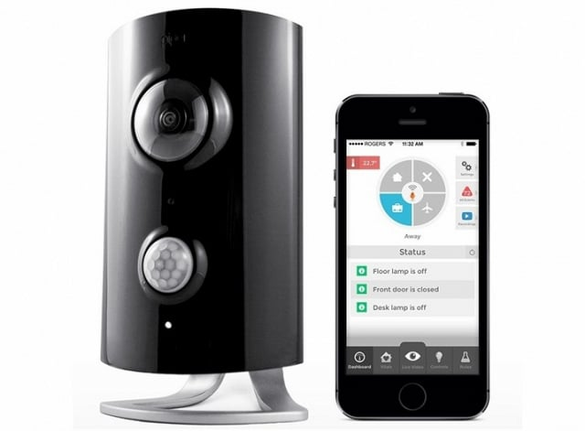

Figure (IControl Networks Piper)

## Identifying signs and signals

To prove this hypothesis, the investigation will be looking for and capturing two types of vital signs from an infant. The two signs being monitored are the early sounds of infant’s pre-cry and motion movements from the infant’s dominant hand. These two elements together will give me the means to be able to get a more accurate prediction of need of hunger.

### Sound

An Australian woman called Pricilla Dunstan was born with a gift of photographic memory, which gave her the ability to hear the difference in subtle sounds that most people will not be able to.

When Dunstan first entered motherhood her gift of sound allowed her to monitor certain patterns in her child’s cries and record them with a meaning, so she could look out for those similar cries when the occur.

Later on Dunstan discovered by listening to the cries of other new-born infants that it was not just a personal understanding that she had with her child. She had learnt that all new-borns make the same 5 types of sound which where all cries of indication for specific needs (Dunstan, 2012).

These sounds are the sounds of a combination of natural infant reflexes that all infants have and cries, which together produce a certain type of distinctive sound (Dunstan, 2012).

In Dunstan’s joint research with researchers from Brown University who have also spent a substantial amount of time researching into infant’s cry’s, they identified that the key to identifying the infants needs in cries was not by looking at the whole length of the cry or focusing on the hysterical part of the crying which is a late indication, but all the relevant information in the cries where at the beginning, which was identified as the pre-cries (Dunstan, 2012).

The 5 pre-cries to be identified are listed below:

**Neh** – Is the sound of indication of hunger, which happens when an infant’s hunger reflex causes them to make sucking motion in their mouth. In conjunction with crying this allows the infant to produce a ”Neh” sound.

**Owh** – Is the sound of indication for sleepiness, which happens when the reflexes of being tired are triggered and the infant yawns and cries at the same time producing an “Owh” sound.

**Heh** – Is the sound of indication for discomfort, which comes from more of a moan/complaint. This type of cries occurs when the child is usually too hot or cold, if they feel uncomfortable in their nappies, uncomfortable or restricted with their positioning.

**Eair** – Is the indication for having need of lower gas being released, which comes from a discomfort emerging from deep in the infants lower stomach and in conjunction with an infants cry it produces a deep low type sound of “Eair”. This signal can also be visually spotted as they may also be pushing their legs out in a battle against the discomfort.

**Eh** – Is the sound of indication for needing to be burped, which occurs when there is air trapped in the top part of the infant’s chest and the body is using a reflex, which tries to push this air out. In conjunction with the sound of a cry it produces the “**Eh**” type of sound.

Dunstan also later discovered that this universal baby language guideline was only applicable to infants within the age criteria of 0-3 months old. This was due to the fact that as they reach the peak of 3-4 months, this reflex’s can start to turn off especially if these reflexes have not been responded to (Dunstan, 2012).

Using this information discovered from my research I will be looking further into how to distinctively decipher the differences of the several pre-cries to be able to specifically identify indications of hunger.

A link to a video of Pricilla Dunstan her self successfully testing out her baby language theory on a variety of new-borns has been provided below.

Video: <https://www.youtube.com/watch?v=PgkZf6jVdVg>

### Motion

An article from “Kellymom.com” that specialises in parenting and breastfeeding states that there are three stages of cues of hunger that this investigation endeavours to capture with sensors (kellymom.com, 2015).

**Early cues:** Consists of the infant smacking or licking their lips, opening and closing their mouth and sucking on their hands and available objects.

**Active cues:** Consists of fidgeting or squirming around a lot and fussing or breathing fast.

**Late cues:** Consist of moving their head franticly from side to side and obviously crying.



Figure (Early Hunger Clues)



Figure (Late Hunger Clues)

Using this information discovered, the aim is to further assist in the task of identifying early indications of hunger by trying to capture these clues.

## Current Solutions

In todays market there are several types of infant monitoring system solutions that utilise different technologies available to help aid in infant parenting.

**UWB Baby Monitor**

In 2010, Russian PHD student and colleagues wrote an article about UWB technology being used to create remote contactless baby monitors.

Unlike traditional baby monitors using video and sound to monitor when an infant is awake or making noises, this baby monitor uses a temperature sensor, microphone and UWB radar to constantly monitor the baby. Assessment of the baby’s actions continue even during sleeping stages as it is designed to detect a obstructive sleeping disorder that occurs in infants called “Sleep Apnoea” which is the cause of SIDS (Sudden Infant Death Syndrome).

They have designed a product named a “Baby Sleeping Guard” which uses UWB radar technology to monitor to constantly monitor the infant and alarm the carer when there are abnormal readings seen.

The Baby Sleeping Guard consists of two main parts, which allow this system to function just at traditional baby monitors.

The first part is the “Sensor Unit” (SU), which is placed in the area of where the infant resides when sleeping to be able to use the sensors embedded in the SU to read the infants body readings.

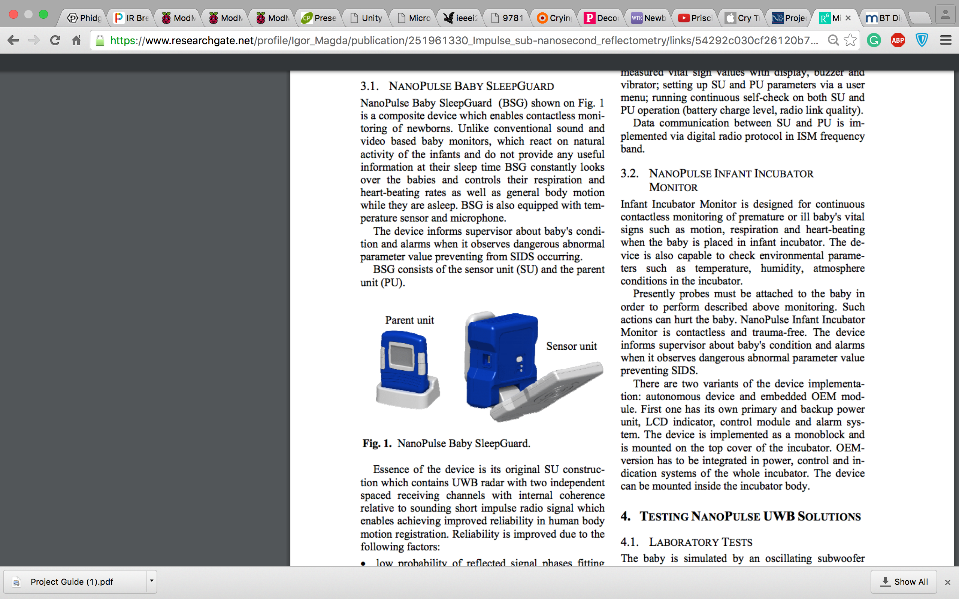

Figure (Sensor Unit)

The Sensor Unit consist of a temperature sensor, microphone and a UWB radar sensor to be able to monitor the infant constantly for long breathing intervals.

The second part is the “Parent Unit” (PU) that is kept with the carer to receive and display messages when information is picked up from the SU, alarming the carer with a buzzer and vibrations.



Figure (Parent Unit)

**KODAK CFH-BVA10**

The KODAK CFH-BVA10 baby monitoring system was nominated as the CES (Consumer Electrics Associations) 2015 Innovation Awards Honouree (search.proquest.com, 2014).

The KODAK CFH-BVA10 baby monitoring system is a two-part system with optional capabilities of also connecting other smart mobile devices to the system.

The KODAK CFH-BVA10 baby monitoring system package originally consist of: a 180°video, night vision, speaker and a microphone capable base unit as the transmitter part of the system, a rechargeable parent unit with a speaker and microphone for two-way digital audio monitoring, a night light with mobile activation and adjustability, a crib sensor and a crib sensor kit to monitor the infants movement, sleeping patterns and temperature for detailed monitoring, two power supply wires for the base unit and rechargeable parent unit along with rechargeable batteries (connectedfamilyhome.com, 2014).

As the system uses WI-FI connection capabilities it allows mobile smart devices such as mobiles and tablets to be integrated into the system as there is a dedicated app available in the “Apple” and the “Google play” app store’s called “iSecurity+”.

This app gives users the ability to monitor their infants visually using the portable HD WI-FI camera, as the provided parent unit does not have visual capabilities. The app also allows you to monitor the infant’s environment using results from the crib sensor and notifies the carer on their smart device via the app, which is accessible at any time and distance as long as there is Internet available (search.proquest.com, 2014).

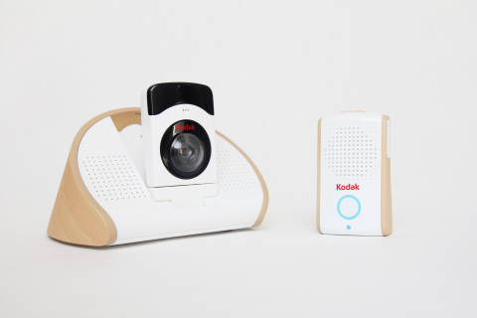

Figure (KODAK CFH-BVA10)

## Summary

All of the current system solutions that have been presented prior to this summary have all achieved their goal purposes, however none of these systems actually do or try to tackle actual issues they just provide capabilities for advanced and for some systems detailed monitoring.

In addition to this, a lot of infant monitoring systems come with a dedicated receiver unit. In contrast to this, the use of everyday smart devices (mobile phones) will eliminate the need of having to carry an extra mobile device around and reduce the responsibility of having to charge multiple devices, making the job of infant caring easier.

Furthermore, rather than having a limited number of receiver units the responsibility of infant caring can be shared between multiple carers as long as they have email capabilities on their devices, whether it be a mobile device or a stationary machine.

Finally, most of the existing systems, which have smart device capabilities, require need of a dedicated app. This incurs greater cost and time, which will be eliminated in the intended system as the need for application development is not necessary because the notification process will be done via email.

This will also allow a wider range of mobile devices to be compatible with the system, as not all devices with email capability have the ability to download apps from app stores.



New Ideas

## Introduction

After analysing the current infant monitoring systems, it is apparent that there is a clear gap for improvement.

This will be done using sensors to monitor infants and pick up on specific sound and movement to be converted into logical data to be transferred to a server for real-time processing.

Once this data has been processed and the values have been queried, the system will send notifications to the carer with a recommended course of action.

This chapter will be elaborating in detail all the relevant components needed to assemble this systematic solution.

## Proposed Idea

As previously discussed, after the analysis of the existing system it is apparent that none of the current infant monitoring systems try to tackle any issues, however they do highlight some technologies that can be capitalised on for the proposed system.

This proposed system would be capable of executing several tasks to be able to achieve the end goal of identifying early signs of hunger indications. The tasks that the system will perform are stated below.

The system will be capable of picking up on particular sensory information, such as sound and movement to be able to analyse the values for diagnoses purposes of hunger indications.

The system will also have the capability to transfer data picked up from the sensors to the server to enable real time data processing and querying to diagnose indications of hunger.

The system will also have the capability to allow extension of multiple receiver units, dividing the responsibility of care for infants between multiple carers and also increasing probability of carers seeing notification.

In addition to this the system also eliminates the issue of having to have extra device with carers at all times and having the unnecessary responsibility of having power/charge another mobile device, which also reduces and extra-incurred operational expense.

The system will be able to instantly notify carers with diagnosed issues and relevant suggestions of course of action as soon as the system has recognised as issue.

This also means that there will also be no additional cost or time, as there is no need for any application development for the notification process. This process only requires an active email address, which users may most likely already have and if they do not there are many free email providers available.

## Proposed solution

Various existing technologies are used in different ways to complete tasks in existing infant monitoring systems. To successfully carry out individual tasks, which will be combined to implement the intended system, various possible solutions are presented and analysed below to make a decision of the best-suited solutions for each task to achieve the end goal.

To obtain the required sign from the infant needed to prove the hypothesis, there are various sensors that can be used to be able to pick some of these up for processing by the server.

### Sensors and Hardware

**Sound/Microphone sensor** – Microphone sensors convert sound into an electrical signal, in either a digital or analogue output reading. This sensor can be used to calculate frequencies of sounds, which is key to identifying early clues of indication of hunger.

This sensor can also be used to be able to pick up active and late signals of indication of hunger. (See 2.9.2 for further description.)

**Proximity sensor** – Proximity sensors use IR (Infrared beams) or electromagnetic fields to be able to pick up changes or interference of the field range or IR beam. This gives the distance from the sensor and the sensor target. This sensor could be used in infant glove wearable’s to help detect early signs of indication of hunger. However using this sensor gives no guarantee that the information required would solely be from the intended sensor target (Hamilton-Smith, Khondjer and Norris, 2012). (See 2.4.2 for early clues of indications of hunger.)

**Accelerometer sensor** – Accelerometer sensors measure acceleration, vibration and motion using an X, Y and Z-axis to pin point positions. This sensor can be used to assist the microphone sensor in identifying early clues of indication of hunger to give better accuracy on estimations. On the other hand, there is also no guarantee that these results will be 100% accurate, as using a type of video recognition sensors like the connect sensor would be more ideal as it would give better accuracy of information. However, due to timing constraints and setting an achievable scope for the project, the accelerometer sensor will be sufficient enough data to further prove the hypothesis.

### Data Transfer

To handle the data transfer process for sending the values picked up from various sensors to sever in the system. There is a combination of protocol and components that can be used to make this possible. This will be done by using UDP, TCP or Serial port communication protocol and a Raspberry Pi or a Arduino Microcontroller.

**User Datagram Protocol (UDP)** – Is a communication protocol used to send short messages over the Internet using datagram packets. These packets have the size of 6553 bytes but can send up to 6557 bytes of data due to the IP header of the packet costing 20 bytes and the UDP header costing a additional 8 bytes (jguru.com, 2012).

This is a protocol used for client to server transitions, which is usually one way. It works by wrapping up the content to be sent in a UDP packet with the destination port number and IP address in the header. The packet will then be picket up by a server that is constantly listening for packets that are sent to its port (jguru.com, 2012). However, this protocol has been classed as unreliable as the protocol does not use any connection establishment procedures like handshake or use any other security for data integrity or error checking (techopedia.com, 2016).

In addition to this, this protocol is also called unreliable, as there is no way to actually confirm that the packet has actually reached the recipient from the sender’s side.

On the other hand, the UDP protocol receives packets in a non-linier structure to which they were sent, this allows better performance, as there is no retransmission of packets in case of loss (techopedia.com, 2016).

**Transition Control Protocol (TCP)** - Is a communication protocol used to send short messages over the Internet using TCP packets. TCP packets are not limited to a packet size, as the data is broken into multiple data packets to be sent. TCP protocol is a more reliable and secure way of transmitting over the Internet. Unlike UDP, TCP uses retransmission request to make sure all sent packets reach the intended recipient and tracks all its packets with sequence numbers to ensure that the packets are received in the same linier order they were sent in (jguru.com, 2012).

TCP is a client to server and rise versa type transition protocol. It does this by establishing a connection between the client and server socket to make a streamed connection using a negotiation. The stream connection and sockets stay open until connection is terminated (jguru.com, 2012).

The TCP also sends acknowledgement receipts for confirmation of receiving packets (jguru.com, 2012).

**Serial port communication** – Is a USB serial communication mechanism that is used to transfer data via USB ports. For this to be possible the RXTX Java library is required for the computer running the server to listen for transmission from the microcontroller. This works by remembering the communication port the microcontroller connects to and the data rate it is sent at.

This type of serial port communication can be used to ensure that real-time data values are being picked up and transported to the dedicated server.

Serial port communication is the best solution for the intended system is requires real-time data collection and only needs to send messages one-way. It was also chosen due to its simplicity of implementation.

It is also the chosen solution, as it will help increase the overall speed of the system as there is no need for packaging data it is just instantly sent.

**Raspberry Pi** – The Raspberry Pi is a full-blown mini computer running a Linux based operating system, which is capable of performing operations just as a desktop computer or laptop would (readwrite.com, 2014).

It has the capability to multitask several processes at a time including background processing, supports USB connections and also has Ethernet and wireless Internet capabilities (readwrite.com, 2014).

The Pi has a 900 MHz processing chip, which is over 50 times more powerful than the Arduinos 16MHz processing chip allowing it to have the capability to run a full operating system (readwrite.com, 2014).

In addition to this the Raspberry Pi has a RAM of 512 MB allowing it to run faster than the Arduino 32 kB RAM.

On the other hand, as the Pi is a full-blown computer, Linux and Python programming may be required. This means more programming knowledge may be required, as you may have to write code on different programming platforms (readwrite.com, 2014).

Furthermore, the Pi can easily be damaged using informal shutdown to terminate its use, making it less robust and more prone to damage.

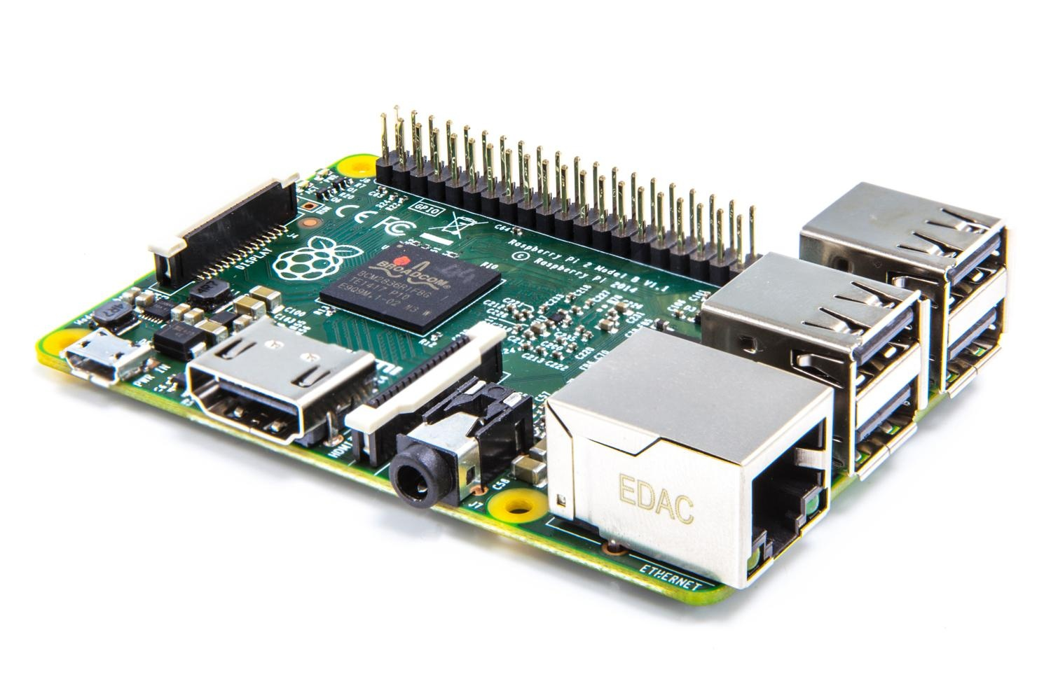

Figure (Raspberry Pi)

**Arduino Micro-controller** - A Microcontroller also described as a MCU (Microcontroller Unit), is a small mini computer with a single integrated circuit, which consists of a processing core, a small amount of RAM memory and programmable input/output capabilities (forum.allaboutcircuits.com, 2012).

Microcontrollers provide the ability of real-time response and processing, as the “Interrupt System” can suspend current processing instructions to launch the ISR (Interrupt Service Routine) handler to perform a separate processing task before resuming to its original task. E.g. converting analogue data into digital data or rise versa (digitaltrends.com, 2015).

Micro controllers also have the ability to transfer data via Bluetooth, wireless or ZigBee. This makes it possible for microcontrollers to send data to a server on the same network for further processing or data storing.

The Arduino has real-time and analogue capabilities, allowing the system to obtain specific readings on the go for instant response from the system and also giving the ability to use a wider variety of sensors, using them to their full extent (readwrite.com, 2014).

The Arduino Integrated Development Environment is most ideal for reading data that requires minimal lines of code. In addition to this, the Arduino is also simple to use as it is not designed to install and run a OS (Operating System), you plug into a computer and you are ready to go (readwrite.com, 2014).

Moreover, the Arduino is quite robust; it is not easily damaged from things like informal shutdowns. To power down the microcontroller the USB cable is simply disconnected from the computer.

See (Appendix D) for further description on Arduinos.

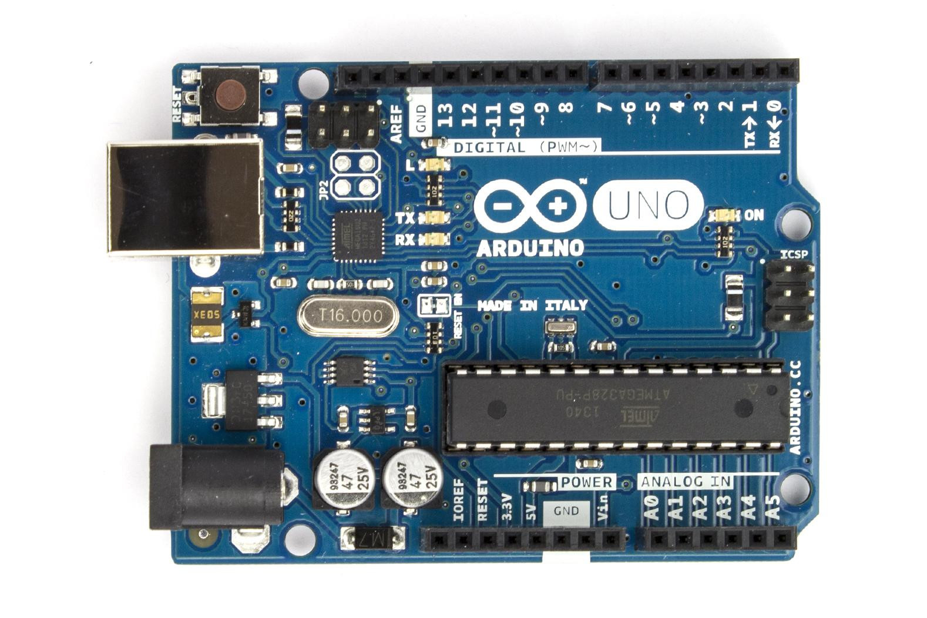

Figure (Arduino)

The Arduino Microcontroller has proven to be the best solution for the data transfer process of this system. This is due to real-time and analogue capabilities without the need of extra hardware assistance.

This solution was also chosen because the Arduino is simple to use and has large community for guidance. A table of specifications for different types of Arduino boards is displayed on appendix D that serves different purposes.

### Processing Data

To handle the server, which does the data processing and querying suggestions of action process of the system, there are two solutions to pick from. These options are to use a stand alone dedicated computer or to use a Raspberry Pi.

**Raspberry Pi** – As discussed prior to this, the Raspberry Pi is a mini computer that runs a Linux based operating system with near enough all the capabilities of a desktop PC.

The Pi has all the necessary capability to be able to set its self up as a server for the intended system. (For further description see the previous comparison).

**Stand-alone computer** – Using a desktop or laptop computer is another possible solution to be able to handle the server component of the system.

Desktop/Laptop computers are more than capable of playing this key component of the intended system, as they have a lot more than the required processing power, which will complete the task faster than the PI.

Using a desktop or laptop machine allows wider range of platforms for coding for developer preference.

To conclude, the best solution for the server component of the system will be to use a dedicated desktop or laptop.

The reason being, the greater familiarity of using a desktop or laptop computer. In addition to this, the Raspberry Pi requires additional setups such as keyboard, monitor and an operating system so any occurring issues in the future would mean more time would be spent fixing issues. Since time constraint is an issue it would be best to use computer for the simplicity, as both methods would achieve the same results.

Furthermore, a special library is required in order to listen to data transmission by the Arduino, which is very difficult to find for the Raspberry Pi.

### Notification

To handle the notification process of the system there are 2 main avenues to take, which are using Restful services or App (Applications). There are 5 possible solutions capable of executing the job analysed. Some of these solutions have been used in similar ways in various existing systems. These solutions are presented below.

**Dedicated App** (Application) – Is a piece of software that is solely designed for the use of a particular purpose, in this case it will be an app designed for communication. They have the capability to receive and send messages on its platform and also to have application notifications specifically for that app. Apps generally must be downloaded by smart devices with app capabilities.

However, the disadvantages of using an application means that data storage and data storage management will be required to hold notification messages. This could be done using SQLite, MySQL or Cloud database storage, which in turn creates more work and processing resulting in the system taking longer to run and the project scope being widened. Also, not all smart devices can use apps so this limits the number of smart devices compatible with the system.

This solution has proven to be unnecessary as all it is needed for is to prove the theory and simply send a message. Nevertheless, it would be beneficial if a particular application message could be ascertained to know it’s about the infant.

**RESTful** (RepresentationalStateTransfer) **API’s** – An application programme interface that allows users to make use of web services in their programmes. It uses the HTTP protocol to use CRUD (Create, Read, Update and Delete) operations to manipulate and represent acquired data. Representations are passed between client and server (searchcloudstorage.techtarget.com, 2014). However, using email RESTful service’s also means it is dependent on that server so if that server goes down, the systems notification functionality will not work.

**Text Local API** – Is a messaging service, which allows sending and receiving of messages via email, MMS and SMS up to 160 words. The disadvantage with this service is it is not free but it is not Internet dependant like the other solutions (textlocal.com, 2016).

This method has proven to not be the best solution for this system as not all smart devices like tablets have text capability and although most people have a mobile phone and are likely to have the device with them, if the battery dies you could still use a tablet or any other machine with email capability.

**POP** (Post Office Protocol) – Is a free messaging service, which was created for a simple way to download and delete messages on a remote email server. It allows you to download messages remotely from the email server, but only once, and deletes the messages from the server once they have been downloaded meaning that the messages will now only exist on the machine/device they were downloaded onto. The emails can consist of different formats of content, allowing files, videos, photos, PDF’s and text up to a size of 20MB (msoutlook.info, 2016).

This method has proven not to be the best solution for the intended system as it limits the amount of possible receiver units to only one.

**IMAP API** (Internet Message Access Protocol) – Is a free messaging service that allows mobile and desktop email applications to access email on an email server. IMAP synchronises the email server and devices used to access emails allowing multiple devices to use the same synchronised email account unlike old messaging services like POP. IMAP also allows categorisation of email into folders and flagging of emails. The emails can consist of different formats of content, allowing files, videos, photos, PDF’s and text up to a size of 20MB (support.microsoft.com, 2016).

On the other hand, IMAP retains messages on the mail server if storage starts to exceed its limit. This could be a huge disadvantage as this same email account could be shared with multiple purposes of emails and there is no guarantee that email space will be free when needed for the system to receive email notifications.

This solution has proven to be unreliable as there is no guarantee in email memory storage management, which can result it the system not being able to notify carers.

**Gmail API** – Is a free messaging service provided by Google, which has the capabilities of email, file sharing, Google search and video chat. Email and video chat are the two services of communication in Gmail, however only the email facility is relevant here, which also has the ability to send email messages to one or more recipients (multiple PU’s). The emails can consist of different formats of content, allowing files, videos, photos, PDF’s and text up to a size of 10GB.

From analysis of the possible notification process solutions, Gmail has proven to be the best solution choice appropriate for this system and project. This decision was made from an accumulation of various reasons. It is simple to integrate and sufficient to prove the hypothesis and there is also no additional incurred cost or time, as there is no actual need for any application development for this process.

In addition, the use of email also opens a wider market of mobile devices that can be used with the system as not all mobile devices have application and SMS capability. The majority of mobile devices are email capable however and this eliminates the issue of having to have extra device present all the time.

The reason why Gmail was picked over POP is because POP limitations of the number of devices that POP allows to download messages limiting the amount of receiver units and not allowing division of responsibility between carers.

The reason why Gmail was also picked over IMAP is because there is no guarantee in email memory storage management and because Gmail is efficient in processing time. By using this, the user can experience a high-quality service as a result of Gmail being designed to handle search functionality, making it 3-10 times faster than IMAP. This is a bonus as the aim is for carers to be notified as soon as possible.

## Functional & Non-Functional Requirements

### Functional Requirements

**FR**: 1 – System must be able to notify user when certain thresholds of conditions are met.

**Priority**: High.

**FR**: 2 – The system must be able to read sound & motion data from the sensors.

**Priority**: High.

**FR**: 3 – The system must be able to read data from multiple sensors at a time.

**Priority**: High.

**FR**: 4 – System must be able to read data from the sensors in real time.

**Priority**: High.

**FR**: 5 – The system must be able to process the data from the sensors.

**Priority**: High.

**FR**: 6 – The system must be able to query decisions of suggestion of action.

**Priority**: High.

**FR**: 7 – User must have Internet access.

**Priority**: High.

**FR**: 8 – User must have active Gmail account.

**Priority**: High.

**FR**: 9 – The system needs audio or real life cries from an infant.

**Priority**: High.

**FR**: 10 – The system must have a list of possible suggestions of action.

**Priority**: Medium.

**Requirements justifications**

In Chapter 2, the analysis has shown that for the intended system to be able to adhere to its purpose the system must be capable of reading real-time, sound and motion data from infants. This must be transported to a server for processing and querying of possible suggestions of actions to be sent to the carer via email depending on what conditions are met.

### Non-Functional Requirements

**NFR**: 1 – The system does not require real life infant for testing.

**Priority**: Medium.

**NFR**: 2 – The system should notify carers with suggestions of action promptly when indications have been identified.

**Priority**: Medium.

**NFR**: 3 – The system suggestions should be presented in clear Standard English and should not be conclusive.

**Priority**: Low.

**NFR**: 4 – Users email account should be handled with care and safely secured.

**Priority**: Medium.

**NFR**: 5 – The application should not crash or malfunction.

**Priority**: Medium.

**Requirements justifications**

As there is a high standard of sense of security and reliability set in the field of infant monitoring systems, the system will run at a high performance level under any circumstance. It will also keep the privacy and integrity of user credentials. The efficiency of this system will be upheld by promptly notifying carers as soon as conditions are identified.

## System Requirements

### Hardware Requirements

**HR**: 1 – Mac computer (OS operating system for need for special library).

**Priority**: High.

**HR**: 2 – Microphone sensor, Accelerometer sensor.

**Priority**: High.

**HR**: 3 – Arduino microcontroller.

**Priority**: High.

**HR**: 4 – Email capable device (mobile device).

**Priority**: High.

**HR**: 5 – Electrical engineering bread board, jumper wires and resistor.

**Priority**: High.

**Requirements justifications**

As discussed in previous chapters it has been identified that all of these hardware components are key in assembling this intended system. Some of these hardware components where optionally chosen due to reasons of simplicity and compatibility.

### Software Requirements

**SR**: 1 – RXTX Java library, JavaMail API, JavaBeans Activation Framework.

**Priority**: High.

**SR**: 2 – Netbeans/java.

**Priority**: High.

**SR**: 3 –Adruino IDE.

**Priority**: High.

**SR**: 4 – Mac OS.

**Priority**: High.

**SR**: 5 – Audacity.

**Priority**: Medium.

**Requirements justifications**

For familiarity reasons Netbeans, Arduino IDE and Java will be the preferred platforms and language to develop the intended system in. In order to use serial port communication for sensor data transfer and Gmail for emailed suggestions for carers, RXTX Java library, JavaMail API, JavaBeans Activation libraries and frame works are required. Audacity is also required for testing purposes to identify frequencies of relevant sounds.

## Architecture

### Overview

This system will use sensors attached to an Arduino microcontroller in order to acquire real time information from infants. This will produce sign that will be converted into logical data for processing. The Arduino will then transfer the collected data from the sensors to the dedicated server for the processing of data and querying of suggestions of actions to notify carers with on their mobile device via email.

The arrows used in the systems architecture diagram provided shows the one-way flow of data in the system.

**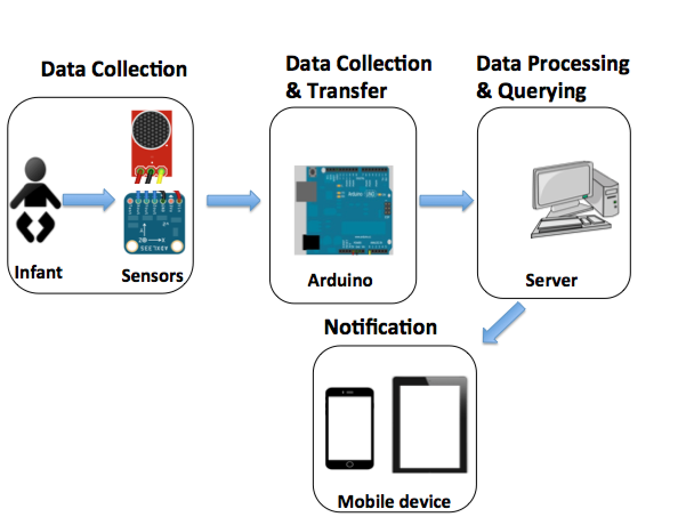**

Figure (Infant Monitoring System Architecture)

The system will be assembled together using a combination of the several individual processes integrated together to achieve the end goal of the project, which is to notify carers with suggestions of indication of hunger.

The system has been broken down into individual processes in order to achieve implementation in milestones. The designs for each individual process are elaborated below.

### Data from the Sensors

The sensors pick up the amplitudes of sounds and convert this information into logical data for the Arduino to interrupt and convert this data into frequencies. These values are then printed out to the serial port for the server to listen to and pick up.

The Accelerometer also picks up values of x, y and z-axis position to check previous and current positions to be able to identify how long and frequent the monitored motion is in the required region. These values are directly read on the server through the serial port.

Table (Sensors and Conditions)

|  |  |
| --- | --- |
| **Sensor** | **Condition** |
| Microphone sensor | Early hunger clues (pre-cries) |
| Accelerometer sensor | Early hunger clues (Hand to mouth motion) |
| Microphone sensor | Active hunger clues (Crying) |
| Microphone sensor | Late hunger clues (Hysterical crying) |

### Server & Data Processing/Querying

The dedicated MacBook running the server picks up the up the frequency values from the microphone sensor and reads the axis values using a serial port for processing. The data is then contrasted against the thresholds of conditions to see if any conditions are triggered.

If any conditions are triggered, the querying process then takes place where the values are further analysed to determine what suggestions of actions are most suitable to notify the carer using the Gmail SMTP RESTful service.

**3.6.4 Mobile device and notification alerts**:

All mobiles devices with email application compatibilities belonging to carers will become potential receiver units, as all notification from the system will be received via email.

## Flow Chart

A data flow diagram has been provided in figure (11) to demonstrate the flow of data throughout the system. It represents data from the start of the system at the sensors all the way through to the recipients of the notifications.

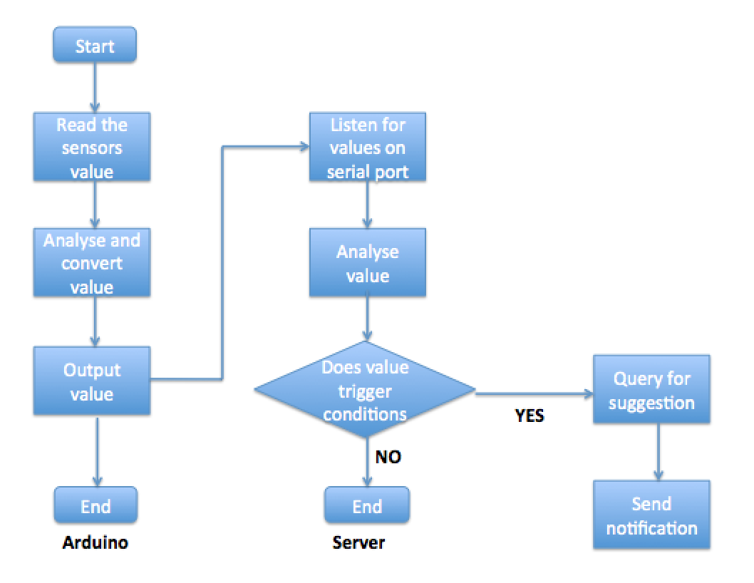

Figure (System Data Flow Diagram)

## Project Plan

### Gantt chart

The appendix (B) shows the initial project plan, however an additional Gant chart was created to show the improvised changes of the completion of the project due to constraints relating to family issues.

See appendix (B) for the original project plan.

See appendix (B) for the updated project plan.

### Contingency Planning

This system will be implemented using different development platforms and tools. This can make file handling an inconvenience when it comes to arranging files for mitigation techniques to protect against unexpected disasters, for example, loss of data.

To protect and mitigate against catastrophes such as loss of data, frequent back-ups should be made on the local machine to be able to go back to the last check points in the instance of irreversible mistakes. Back-ups should also be made externally in case of loss of data on the whole machine.

External back-ups can be generally made using two general methods; using an External flash or hard drive or cloud based storage. However, both methods have their advantages and disadvantages.

Using cloud based solutions such as Drop box, are reliable, free and allow you to access your data from any where on any Drop box application capable device or via website. However, cloud based solutions are internet dependant meaning if there is no internet access you will not be able to acquire your data. In addition to this, cloud based solutions like Drop box only offer a limited amount of space up to 5GB for free and any more memory exceeded over that limit must be paid for at an OPEX (operational) expense.

Using hardware solutions like a hard-drive or flash-drive comes with an upfront CAPEX (capital) expense, which will vary, on the brand and capacity of memory. However, this type of method usually has a greater capacity of storage that cloud passed solutions and are portable as they can be taken anywhere with you and can be accessed on any machine compatible with the flash or hard-drive. On the other hand, if it is not present with you the data cannot be accessed and if it is lost or damaged the data will be lost forever.

Ideally the best solution is to use both types of back-up procedures to be safe instead of sorry.

## Summary

In summary, this chapter have developed a solution from many viable existing technologies that can be utilised to overcome issues and limitations of infant monitor systems analysed in the previous chapter.

Each process and component have been analysed and elaborated on how they will play a key role in implementing the intended system and diagrams have also been used to further elaborate on purposes of each component and the flow of data throughout the system from start to end.



IMPLEMENTATION

## Introduction

This goal of this project is to be able to prove if hunger can be predicted using small-scale sound and motion. Assessing the problems faced in infant parenting and analysing current infant monitoring systems in Chapter 2 continued to Chapter 3 in which various technologies that can be utilised for this purpose were evaluated. Chapter 4 will illustrate the journey of implementation of the various selected technologies integrated together to produce the intended system.

Each component and concept of the system solution will be elaborated on in detail in this chapter, emphasising on each component being implemented to meet the requirements set in Chapter 3, to meet the end goal of the intended system.

## Methodology

**Traditional**: Traditional based methodologies usually take an incremental approach to system development planning. This means that a linier structure of processes is followed to achieve the end goal with each process being dependent on the process prior to it (optimusinfo.com, 2016).

They involve thorough detailed initial planning and a commanding style of leadership, owing to its resistance to change. These types of methodologies are heavily document oriented and driven to help capture and execute the project successfully.

Waterfall – The waterfall is a traditional system development life cycle type methodology model. It is an incremental type methodology that has 5 main general steps involved which are Analysis, Design, Implementation, Testing and Maintenance.

It has a linier and rigid process structure with set target goals to be able to move forward to the next stage. Strict requirements are required and set, as planning stage is done once and this model is not open to change (istqbexamcertification.com, 2016).

Advantages

* Enforces discipline and clear phases.
* Progress can easily be identified and new team member can be brought up to date on project status easily.
* Requirements can be identified and agreed before coding to avoid back tracking.
* Formal specification allows parallel development.

Disadvantages

* Does not show what the system really needs until the end.
* Requirements can be written down ambiguously.
* Heavy documentation can be a waste of valuable time.
* It is not iterative; most issues are spotted during the testing stage so all problems are found after the development.
* It is not open to change after the planning process, so if the planning was wrong the whole project may be forfeited.

**Agile**: Agile based methodologies generally take an iterative approach to system development planning. This means that there is constant planning, design and development throughout the life cycle of the methodology making it open to change (optimusinfo.com, 2016).

It is an alternative solution to traditional methodologies, as the processes involved are not solely completed in particular stages.

Scrum – The Scrum methodology takes an iterative and incremental approach to project management by breaking down big projects into smaller milestones to be completed. These milestones, called sprints, are given priority and time limits to complete prioritised task one after another. (smallbusiness.chron.com, 2016).

This methodology is susceptible to change of requirements, though requirements cannot be changed during sprints. This methodology has three phases involved.

This works by iterating from planning to sprints until all task are completed and the project reaches its closure stage where the project is finished.

Advantages

* Open to change.
* It is easy to monitor progress looking at milestones.
* Testing throughout the development.
* Task can be prioritised.

Disadvantages

* Scope creep.
* It requires clear definition to be able to organise the project.

Rational Unified Process (RUP) – The RUP methodology takes an iterative and incremental approach to OO (Object Oriented) system development. This process was designed to improve quality and to reduce project failure risk, as it repeats each phase of the cycle until satisfaction is reached and if something goes wrong you can resume from the last milestone instead of discarding the whole project (my-project-management-expert.com, 2009).

This method has four main stages to it; Inception, Elaboration, Construction and Transition. Each stage has well defined Aims, Activities, Inputs and products. In addition to this, all phases iterate through the 5 workflows, which are (Requirement, Analysis, Design, Implementation, Test) but some are focused on more than others.

Advantages

* It identifies what requirements are really needed.
* Less time is wasted on documentation and more time is spent on development.
* It is open to change after initial planning phase.
* If something goes wrong, you can resume from the last milestone instead of discarding the whole project.

Disadvantages

* Can lead to scope creep as requirements can change and grow.
* It requires experienced developers.

After evaluating the various methodologies and their pros and cons, it is fair to say that the RUP methodology proved to be most suitable for the project.

This decision was made due to its repetitive nature of the methodology allowing problems to be identified in the early stages of implementation. This effectively avoids catastrophes when it comes to testing. The method is also open to change allowing requirements to be re-assessed and changed for adaption if needs be.

## Analyse baby cries

Audacity (a Fast Fourier Transfer software) was used to analyse multiple recordings of various infant cries related to the DBL theory. This gave the ability to differentiate the average frequencies of the 5 general cries allowing a threshold of 1000 Hz – 1100 Hz for hunger conditions to be identified using a plot spectrum frequency analysis tool.

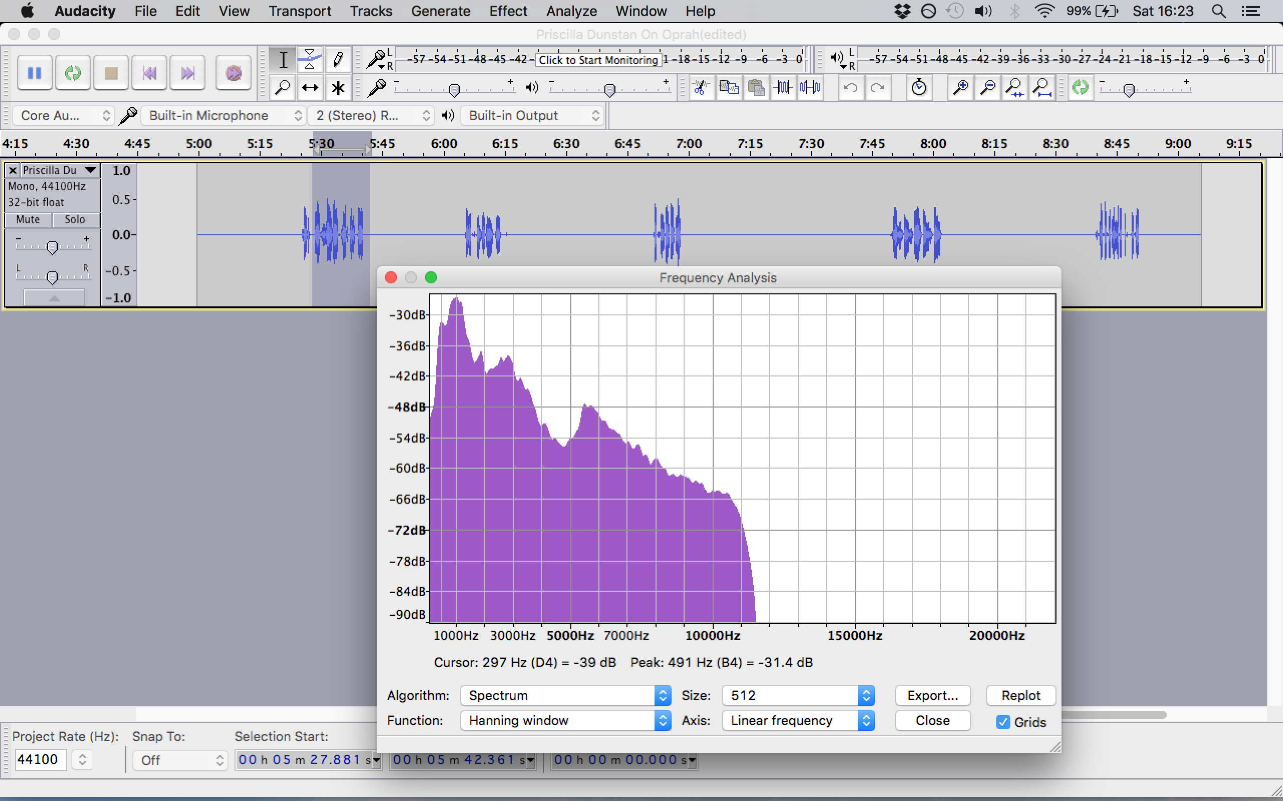

Figure (Audacity plot spectrum frequency analysis tool)

Figure (12) shows the audacity software with an imported audio file of a collection of infant cries related to the DBL theory. It also shows the plot spectrum frequency analysis tool being used to get an average frequency reading of the types of cries.

## Programming environments

Different development environments where utilised to assemble the project together. These development environments where selected due to compatibility of task and also for familiarity.

The table below shows what development environments were used and what their purposes are.

Table (Development Environments for various tasks)

|  |  |
| --- | --- |
| **Development Environments** | **Used for** |
| Netbeans | Serial port listening, processing & querying data, notification and reading accelerometer data. |
| Arduino IDE | Reading Microphone sensor data. |

## Connecting sound sensor to Arduino

To set up the Arduino with sensors attached to it required me to understand the basics of Electrical Engineering. The Concepts of power voltage, ground and signal had to be learned in order to create a fully connected stable circuit.

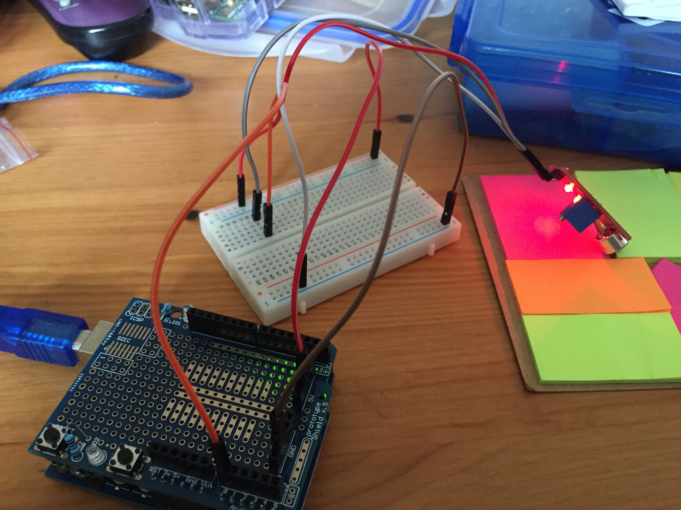

Figure (Arduino Electrical Engineering set up)

Figure (13) shows the set up of the circuit. The circuit involves an Arduino microcontroller, a breadboard, a microphone sensor and multiple jumper wires connecting the circuit together. It also shows the jumper wires connected to an analogue I/O port to allow analogue readings.

The guide presented below in figure (14) was used to create the circuit according to the sensor attached to the Arduino. However, the manufacturer of the sensor usually provides instructions on how to connect their sensors as well as example code.

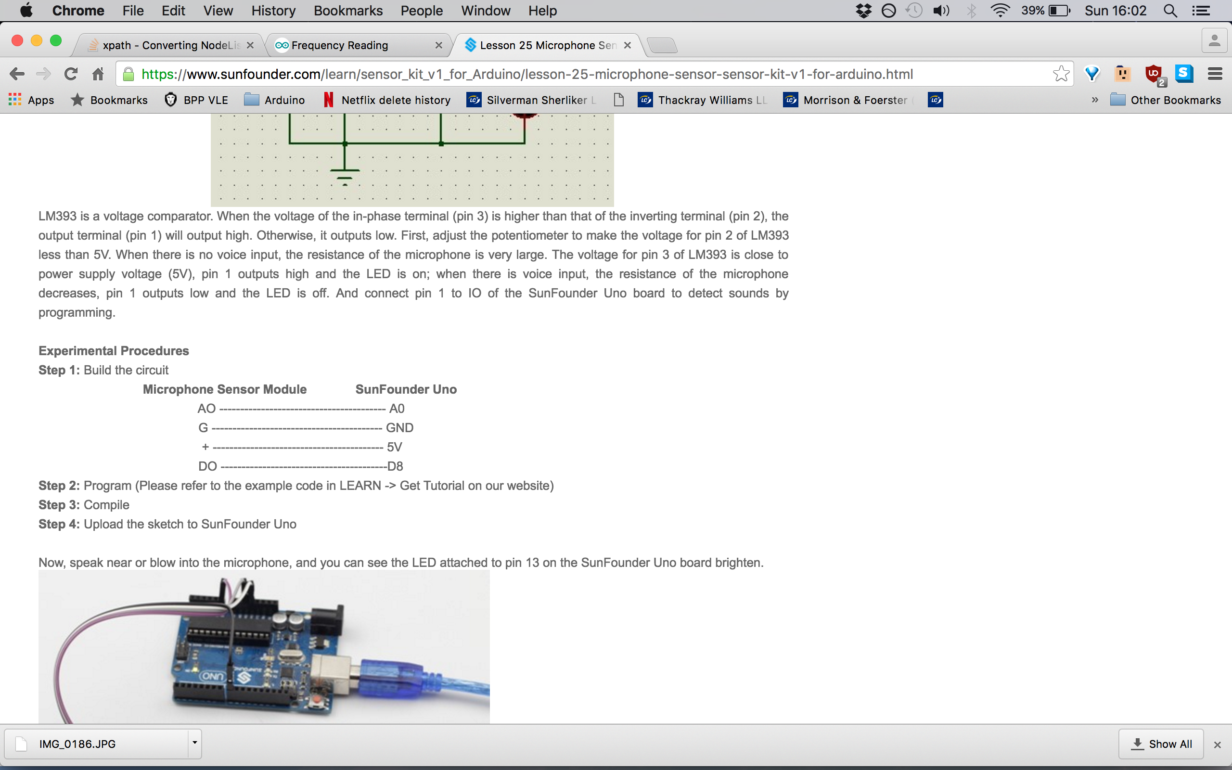

Figure (Arduino & Sensor set up guide)

## Obtain frequency

After finding a threshold and setting up the Arduino and sensor attached to it, the first part of software development takes place using the Arduino IDE.

An Arduino sketch was then created to pick up the amplitude values from the microphone sensor to then convert them into a frequency value that would be printed out on a serial port for the server to listen to. Figure (15) displays the code used in the Arduino sketch.

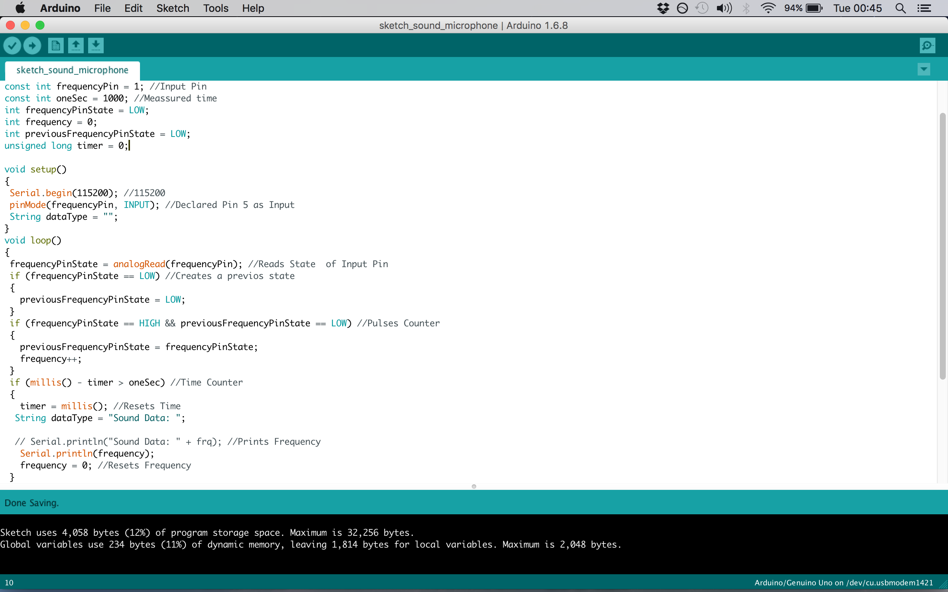

Figure (Arduino IDE code)

### Finding more accurate threshold

However, using the Audacity software does not take into consideration the distance from the infant, the microphone interference and the quality/sensitivity of the microphone, hence why the average threshold obtained from audacity was reduced.

To get an average threshold taking the constraints of distance, interference and quality/sensitivity of the microphone into consideration, the microphone sensor was placed at a 20 cm distance to resemble a realistic positioning of an infant in their cot. Capturing multiple frequencies of the cries at this distance, allowed a realistic threshold average to be identified.

This same method was used to obtain all of the sound condition thresholds.

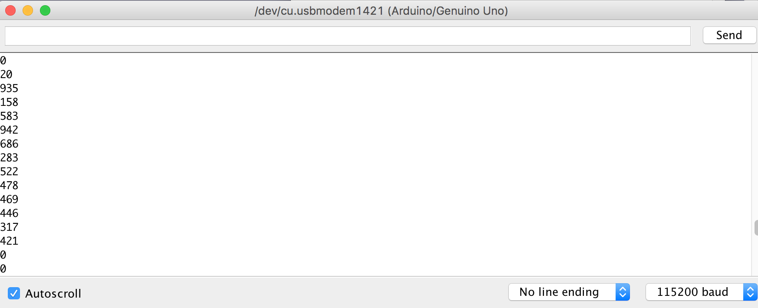

Figure (Arduino IDE Serial port listener, listening to cry frequencies)

Figure (16) displays the serial port collecting multiple frequencies of infant hunger related cries used to acquire a threshold average.

## Serial Communication

The serial port listening and reading process is made up of 2 key processes to get the acquired information from the infants to be able to start the processing stage of the system. However, to be able to use serial port communication, the RXTX library was required to use this type of communication.

## Obtain motion

**Phidget spatial 0/0/3** – In order to obtain secondary early hunger clues, an accelerometer was used to get the direction of acceleration to be able to give an indication of an infant’s hand being in or around their mouth region.

In order to acquire an accurate threshold of axis’ for the region/direction of the infants mouth area, various tests were conducted to give a to give the three possible axis’ ranges.

To operate the Phidget spatial sensor, the phidget21.jar library was required to be able to use required class functionalities.

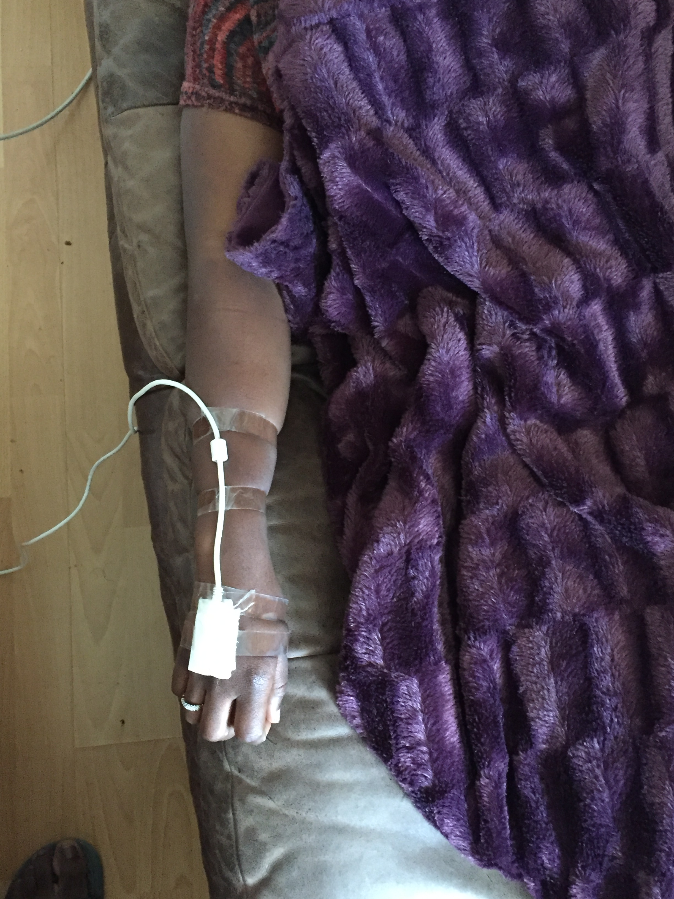

Figure (Spatial Phidget sensor threshold test)

Figure (17) displays tests being conducted in a laying down position to represent the infant in their resting position, with the accelerometer being stuck to the test patient’s hand to represent a wearable sensor, as this would be the most ideal way of applying this sensor. In addition to this it also provided more stability for the test, ultimately increasing accuracy of results.

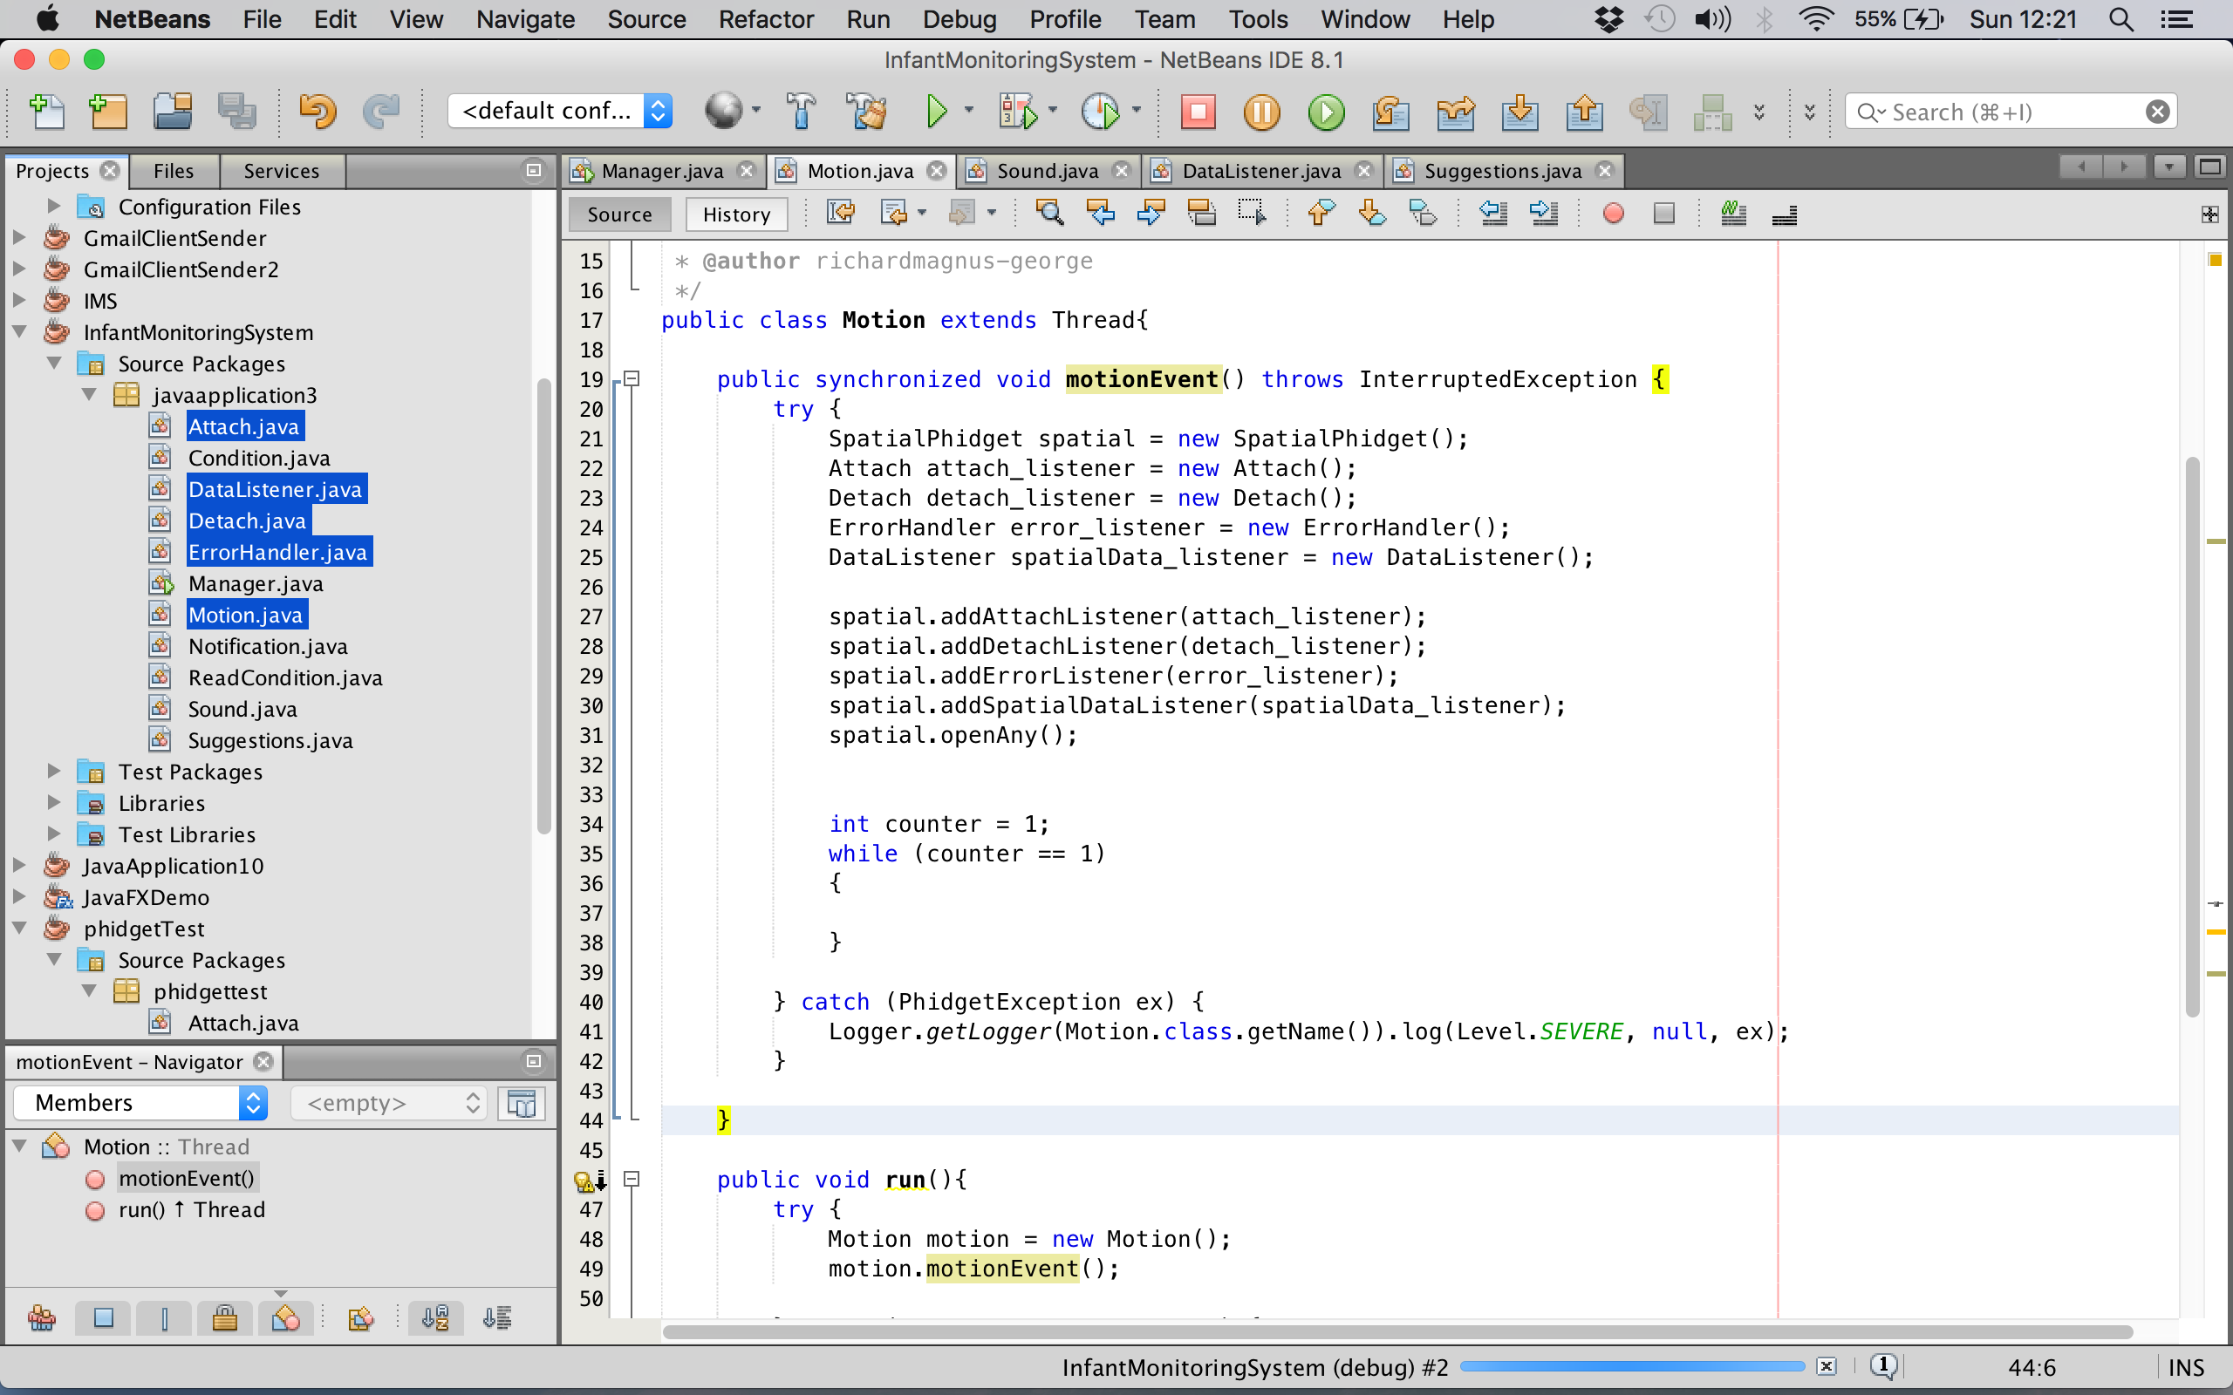The spatial Phidget implementation consist of 4 major components, these are an attachment listener for detecting when the sensor has been plugged into the computer, a detachment listener for handling when the sensor has been unplugged from the computer, error handling and finally a data listener.

Figure (Spatial Phidget 0/0/3 Code1 (Motion))

Figure (18) displays the class and method of how all the spatial phidgets sensors methods are called to actually run the sensor.

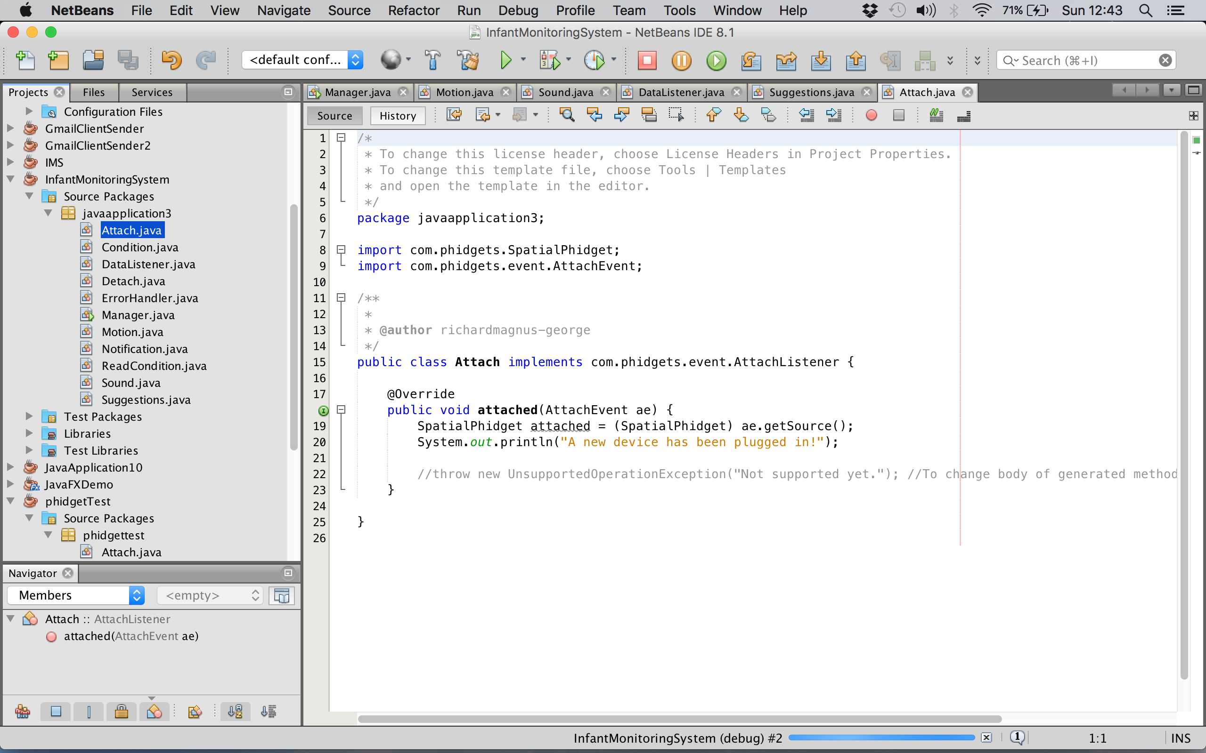

Figure (Spatial Phidget 0/0/3 Code2 (Attach))

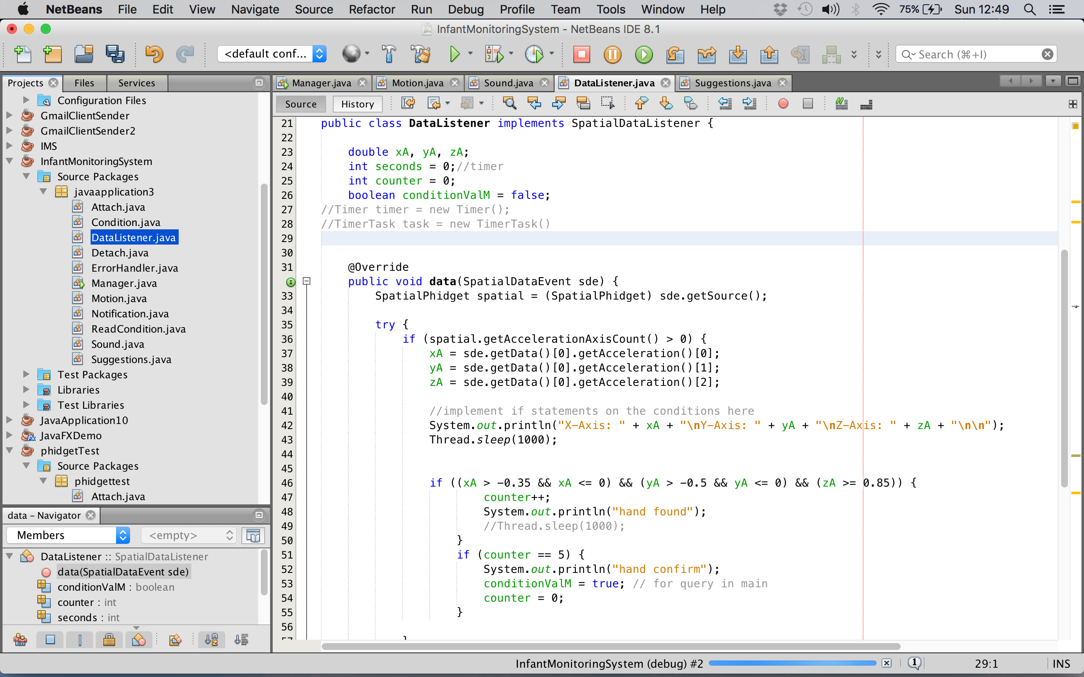Figure (19) displays the class and method of how the sensor actually attaches to the programme to establish a connection.

Figure (Spatial Phidget 0/0/3 Code3 (Data Listener))

Figure (20) displays the class and method of how the spatial sensors data is actually being read from the accelerometer.

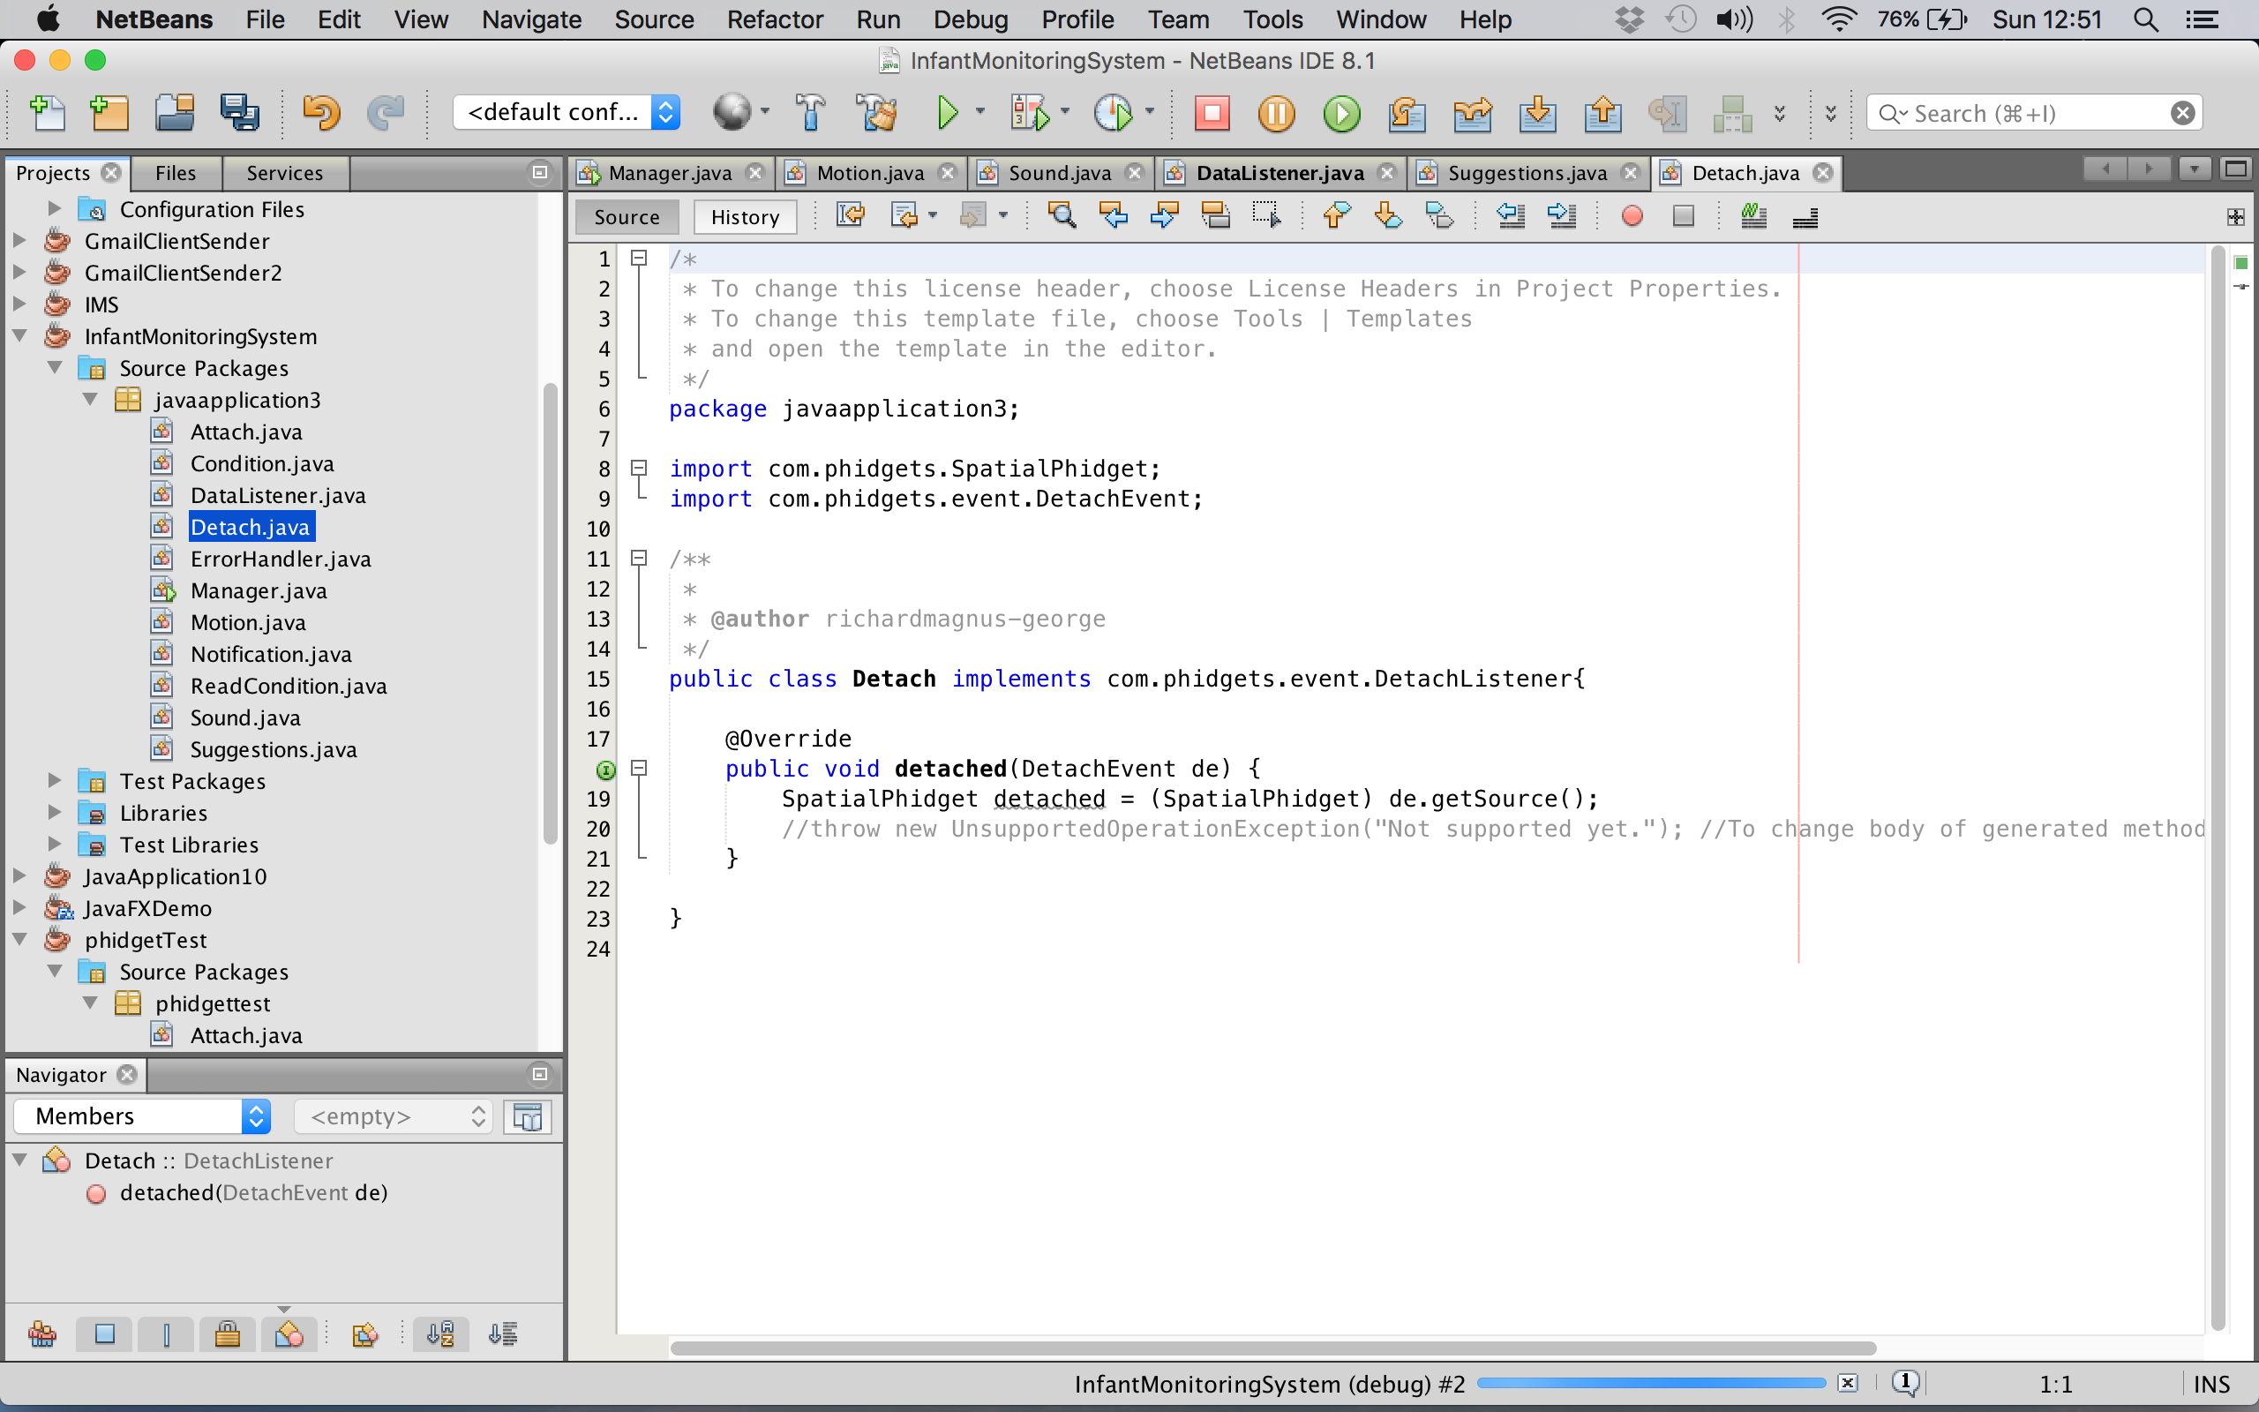

Figure (Spatial Phidget 0/0/3 Code4 (Detach))

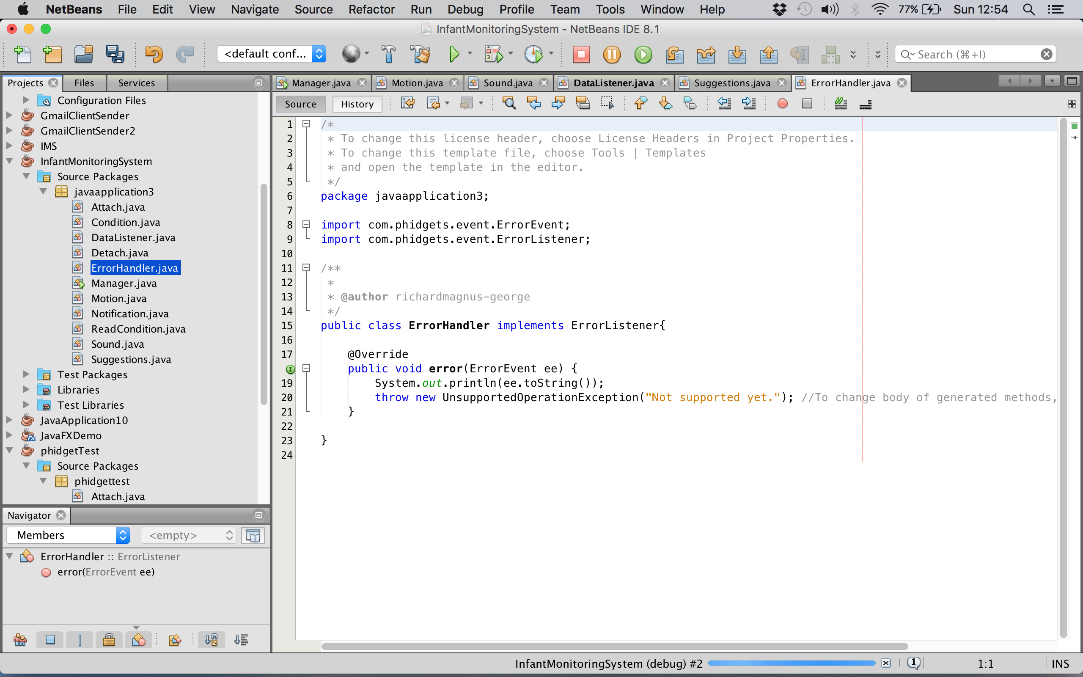Figure (21) displays the class and method of how the spatial sensor cancels the connection between the programme and the sensor when it is being disconnected.

Figure (Spatial Phidget 0/0/3 Code5 (Error handler))

Figure (22) displays the class and method of how the spatial sensor deals with errors.

Initially the idea was to implement all sensors into one wireless unit that can transmit values wirelessly across a network. In real life using wires could be hazardous and having to have the dedicated server close by to connect via USB it not practical or comfortable for the infant, as wearable’s could be utilised which is further elaborated on in chapter 6.

## Setup conditions

To set up the systems conditions, the conditions where created and stored in a XML file, which where then read into the system as Java objects using a parsing method called XPath to extract the relevant information.

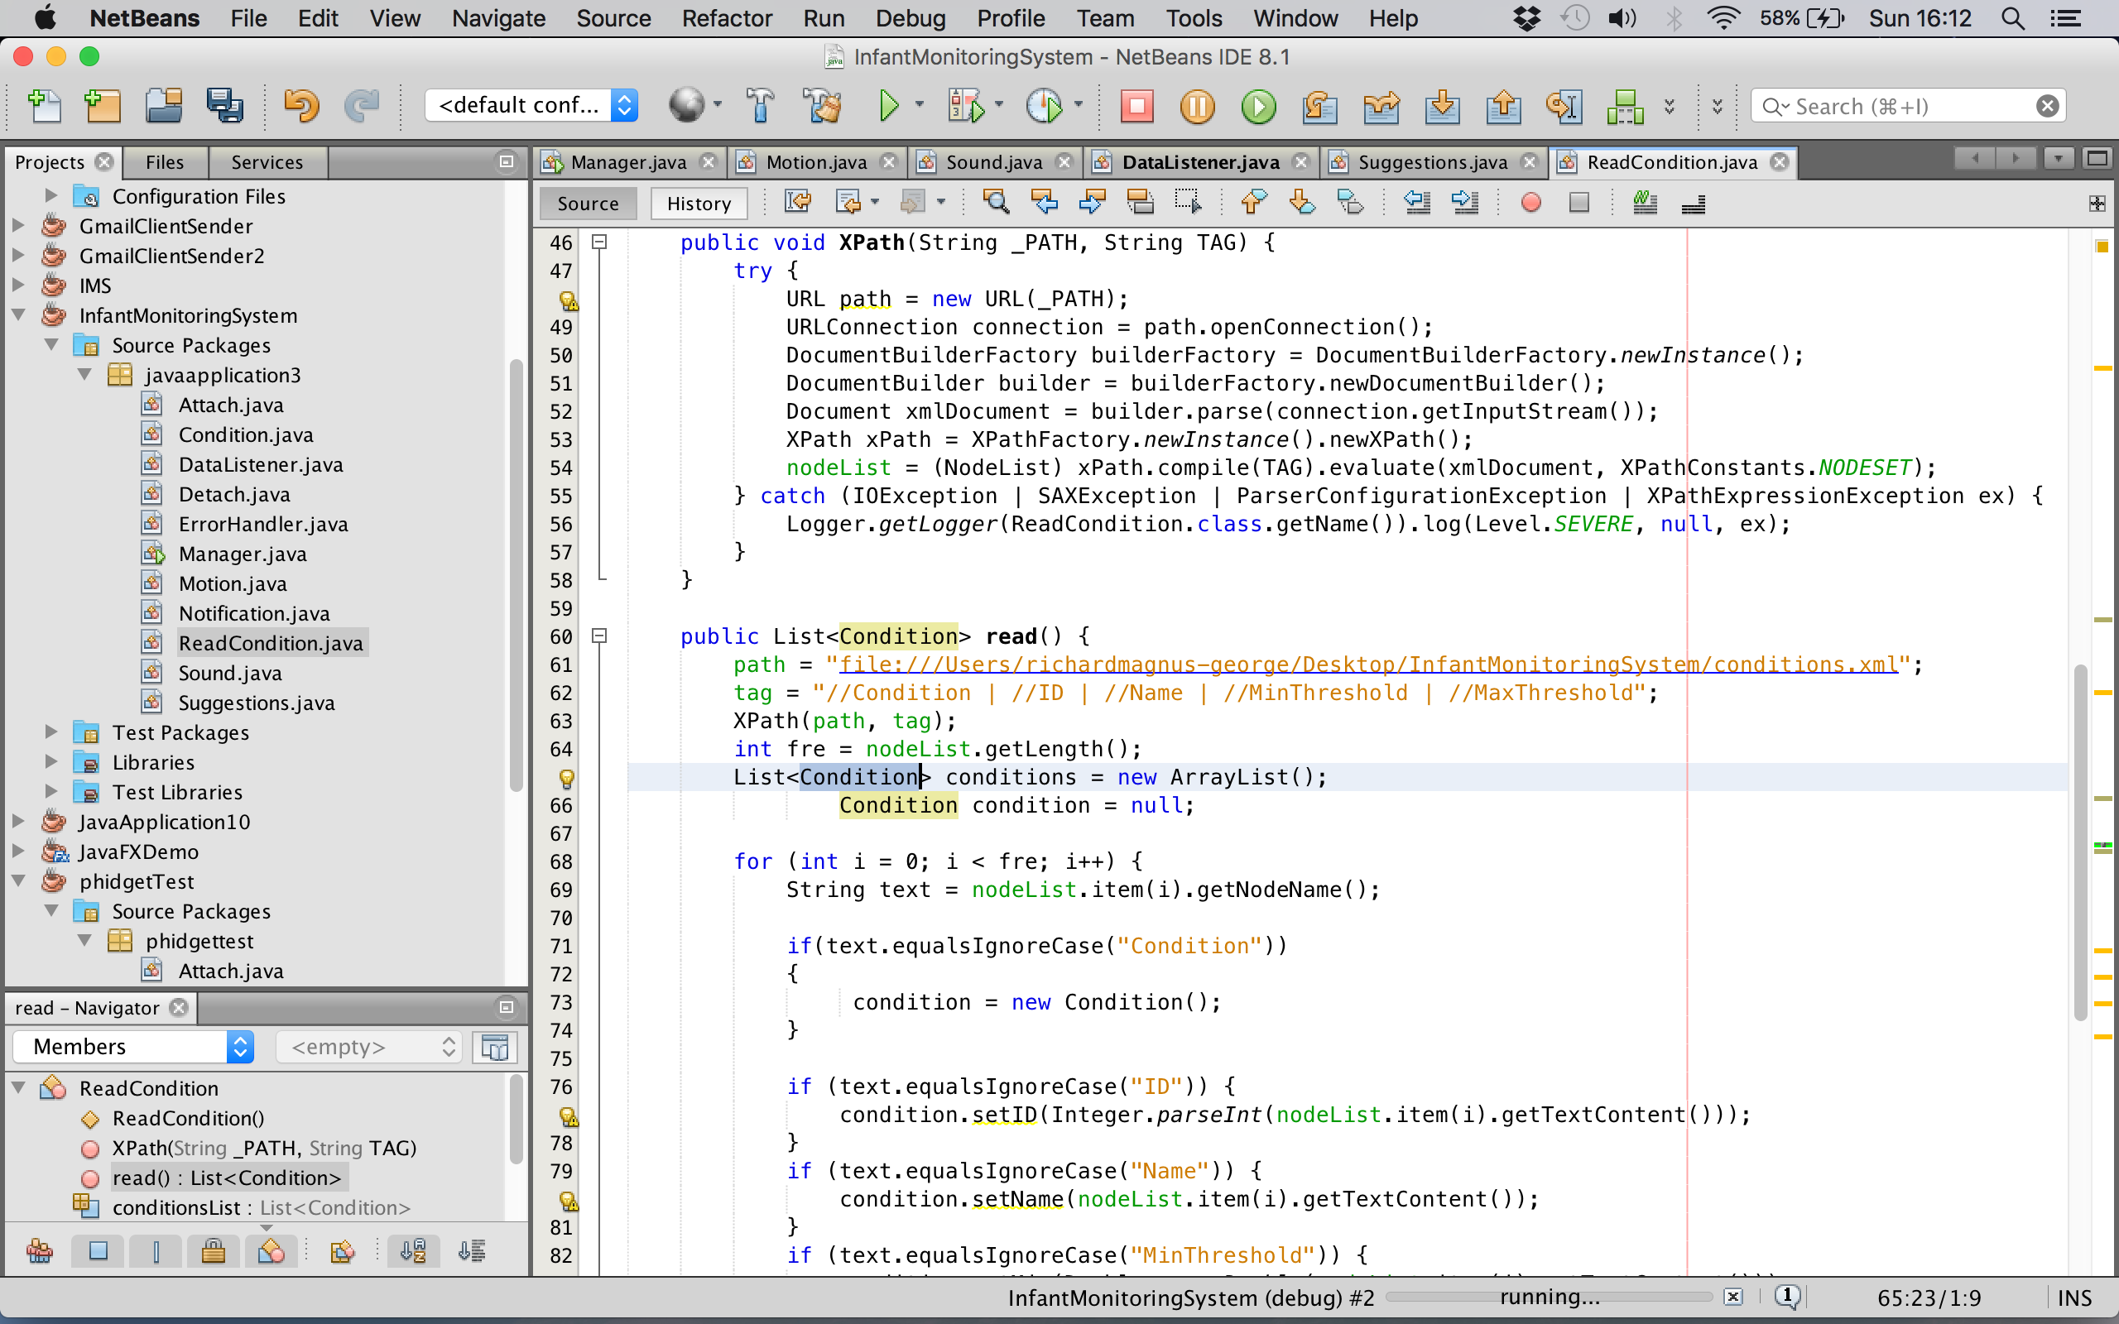

Figure (Read Conditions code)

Figure (23) displays the XPath parser and the read method reading through the XML file and extracting relevant information to be added into the body of a condition object.

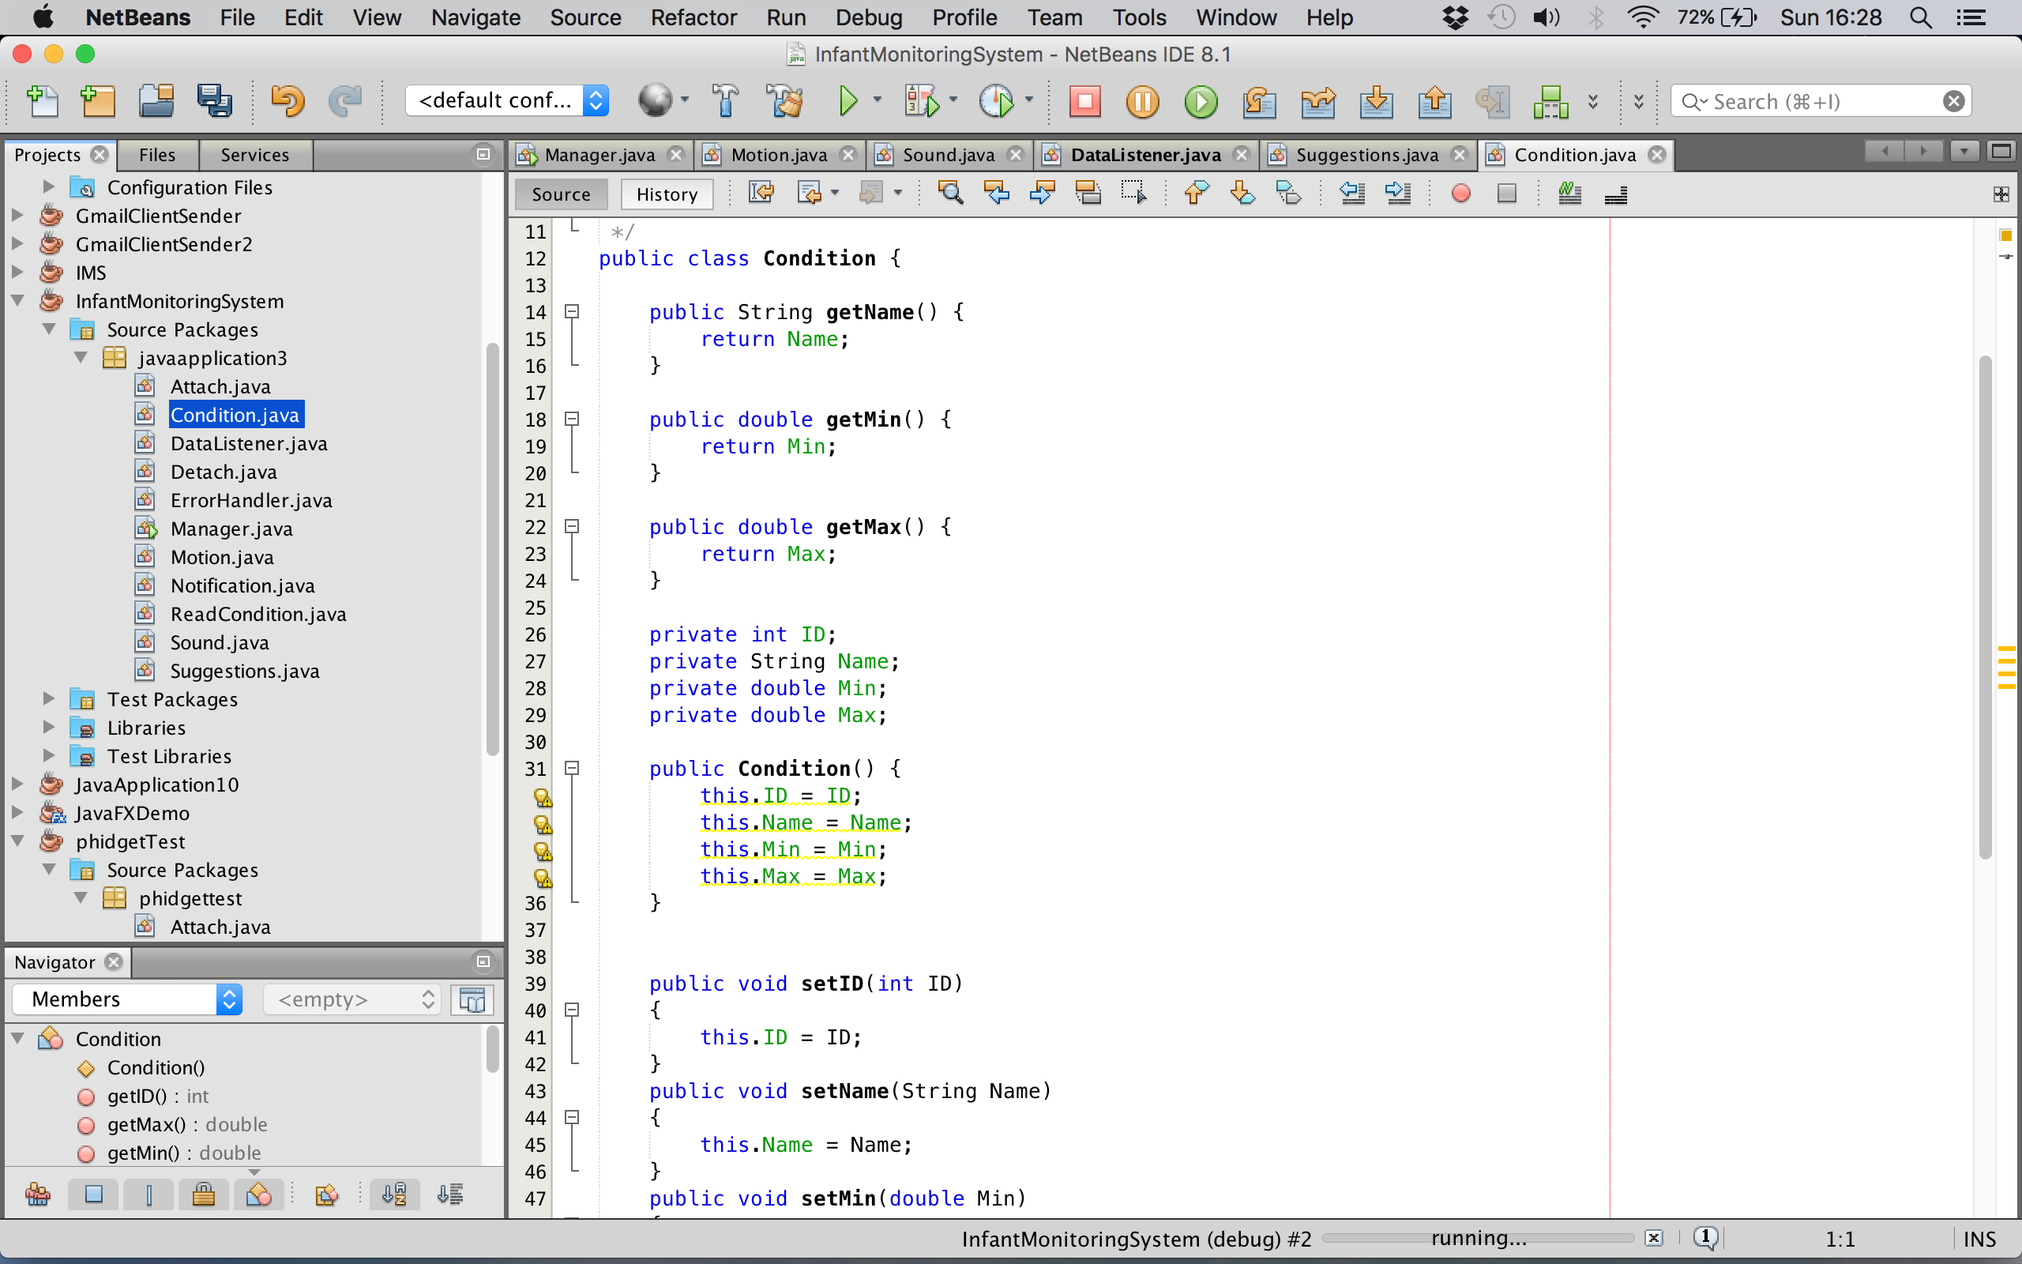

Figure (Condition body code)

Figure (24) displays the body of the conditions. It also displays the getter and setter methods to be able to create condition objects from the XML file.

## Process Data

Processing data () – The data processing is the heart of the system, which contains all the main functionality. It consists of two main concepts to make this process possible. These are; Condition checking and Suggestion querying.

**Condition check algorithm**

Cries from 5 different babies where obtained, using those sounds an average frequency was summed from all the babies tested. In order to be able to get a fair value to compare against the sound condition threshold, real-time cries where listened to for a set period of time to store frequencies into a link list and calculate the average frequency. This was then used to compare against the conditions threshold. In addition to this, in order to get a definitive triggering value for the accelerometer condition the motion that indicated hunger must occur 5 times or must be in that position for five consecutive seconds. If both conditions are triggered, the notification process is run and it sends the email and notifies the carer with a relevant suggestion from the suggestion list. However, if no match ifs found the link list of frequencies is cleared and the process is repeated.

The conditions checking for sound takes place in the Sound class in a method called Process Sound. It iterates through all the conditions thresholds to see if any of the conditions has been triggered and also updates the conditions value for the fore coming suggestion process.

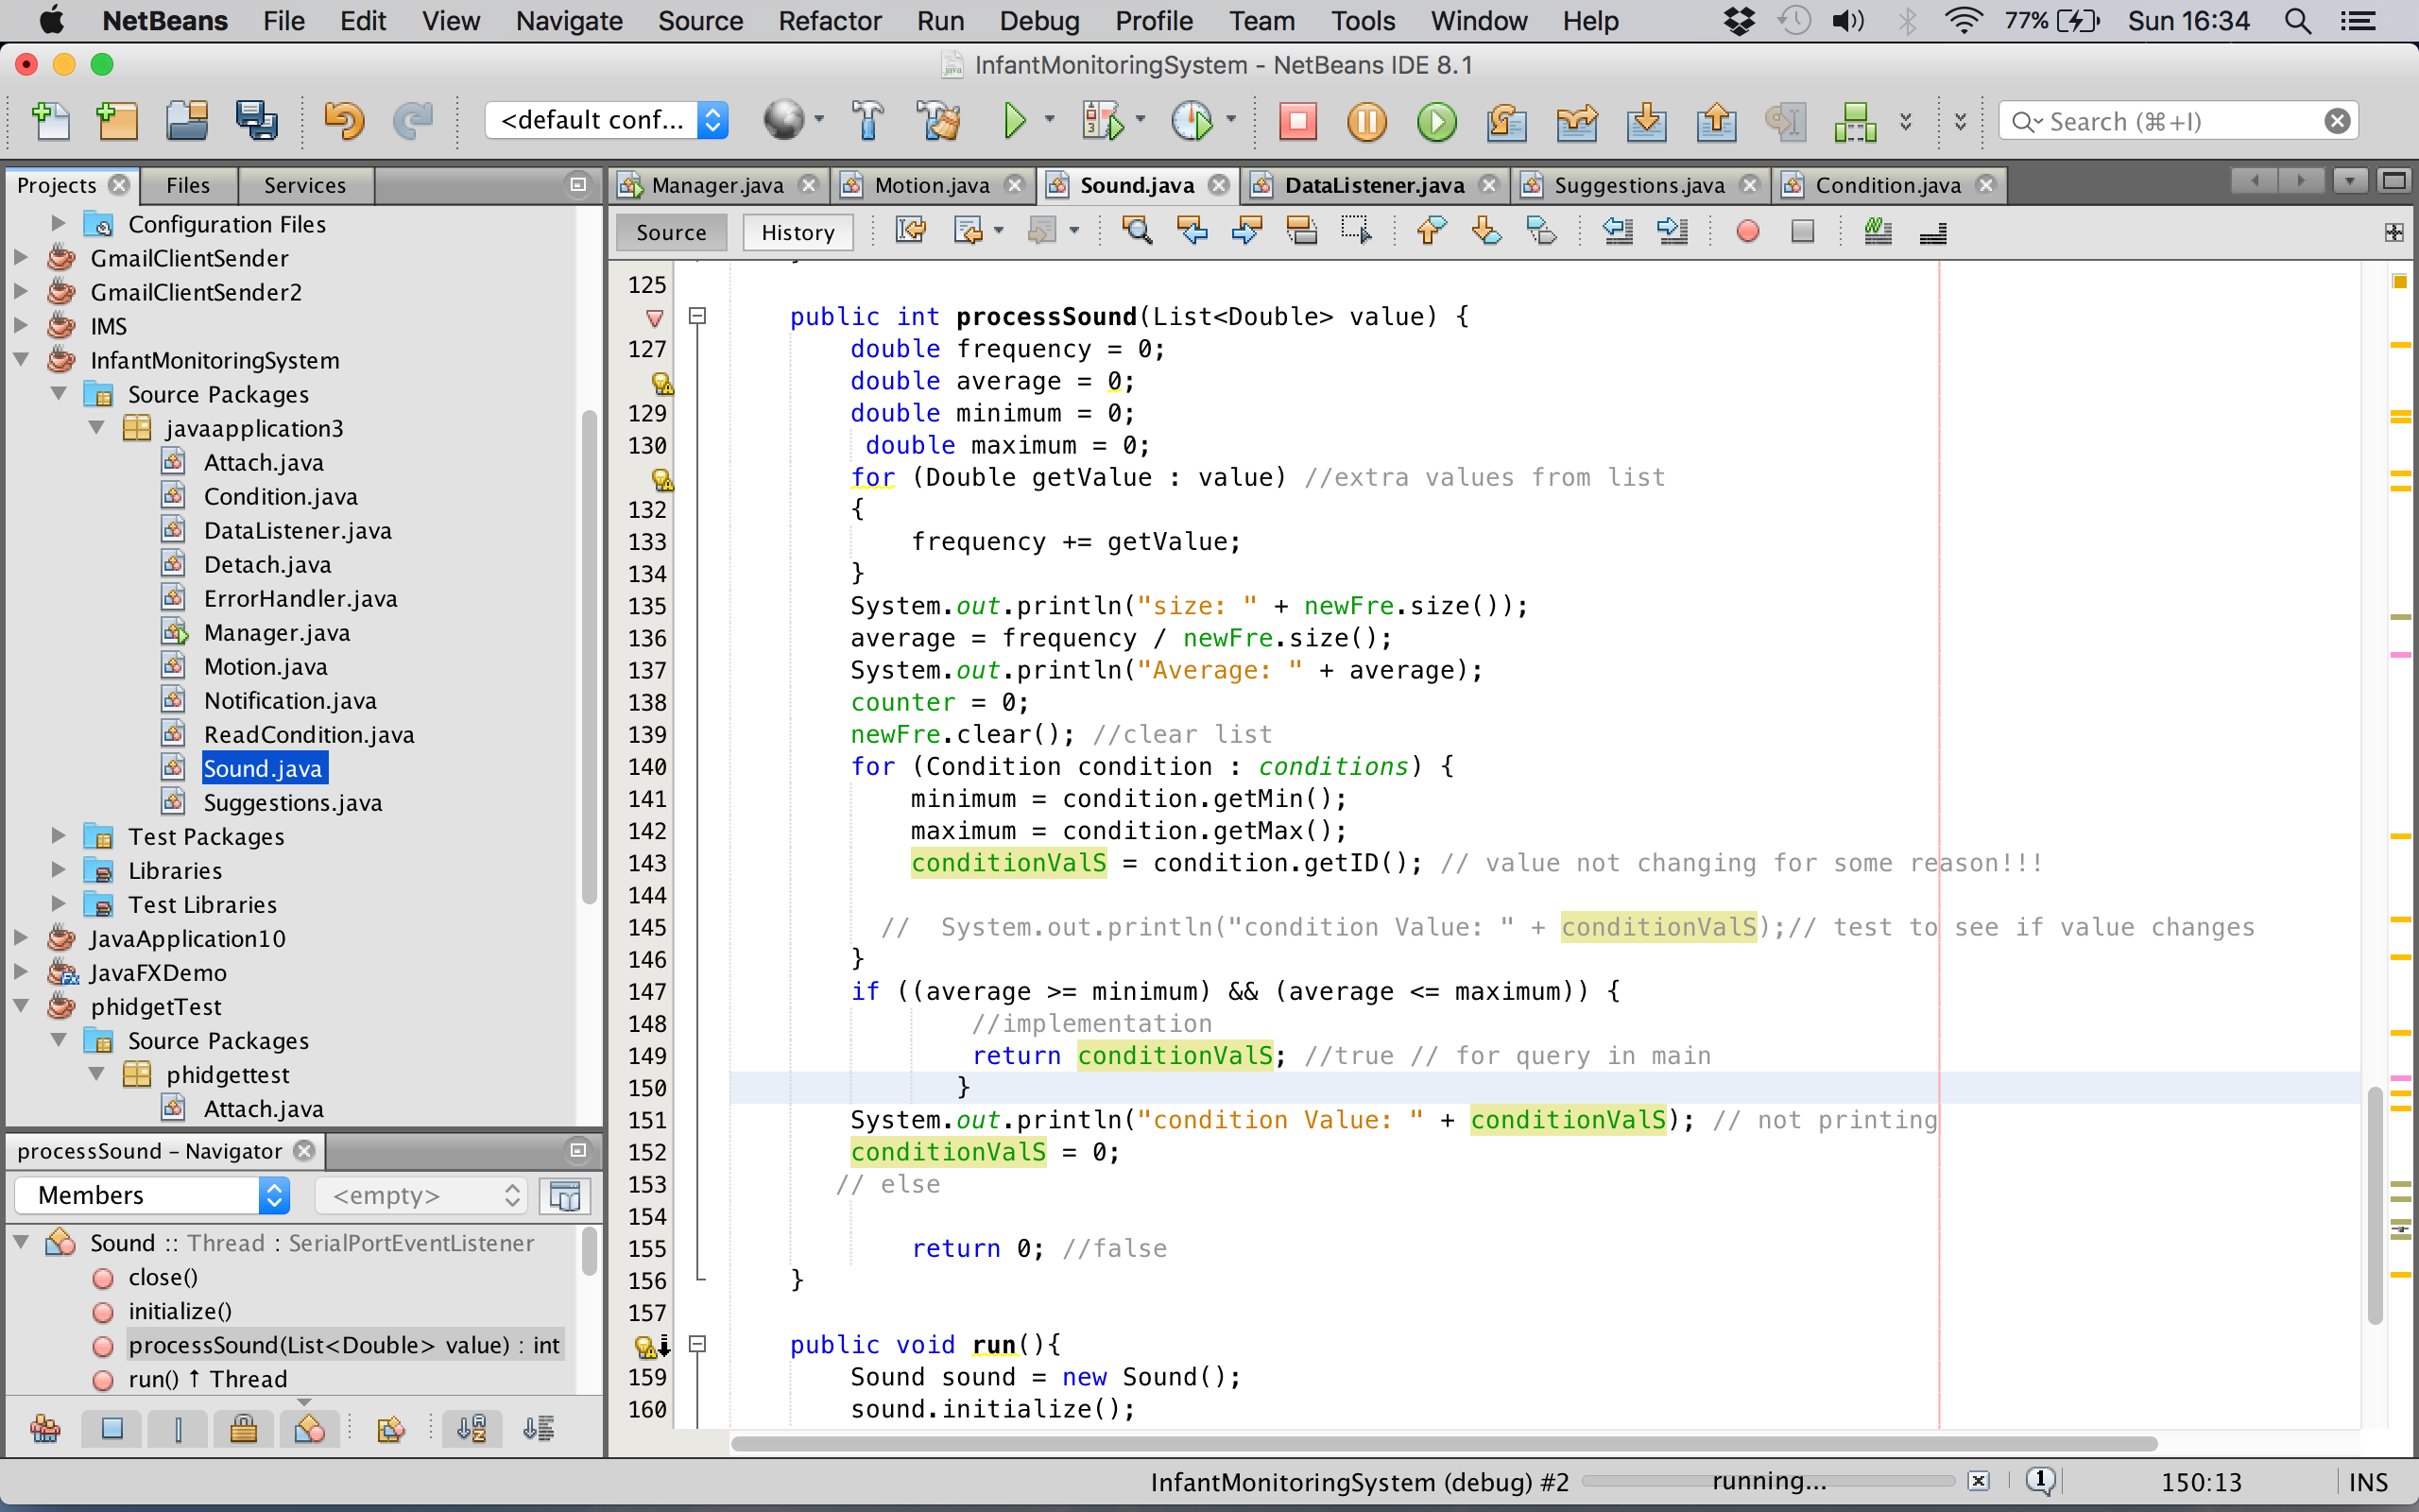

Figure (Sound Condition checking process)

Figure (25) displays the process of condition checking where the minimum and maximum thresholds of conditions are being queried against averaged values of accumulated real time infant cries.

The condition checking process for motion takes place in the Data Listener class in a method called data. As this condition only returns true or false to represent the motion is indication hunger or not, this condition checking will be hard coded into the data listening method as it is not necessary to have a XML file dedicated to one condition.

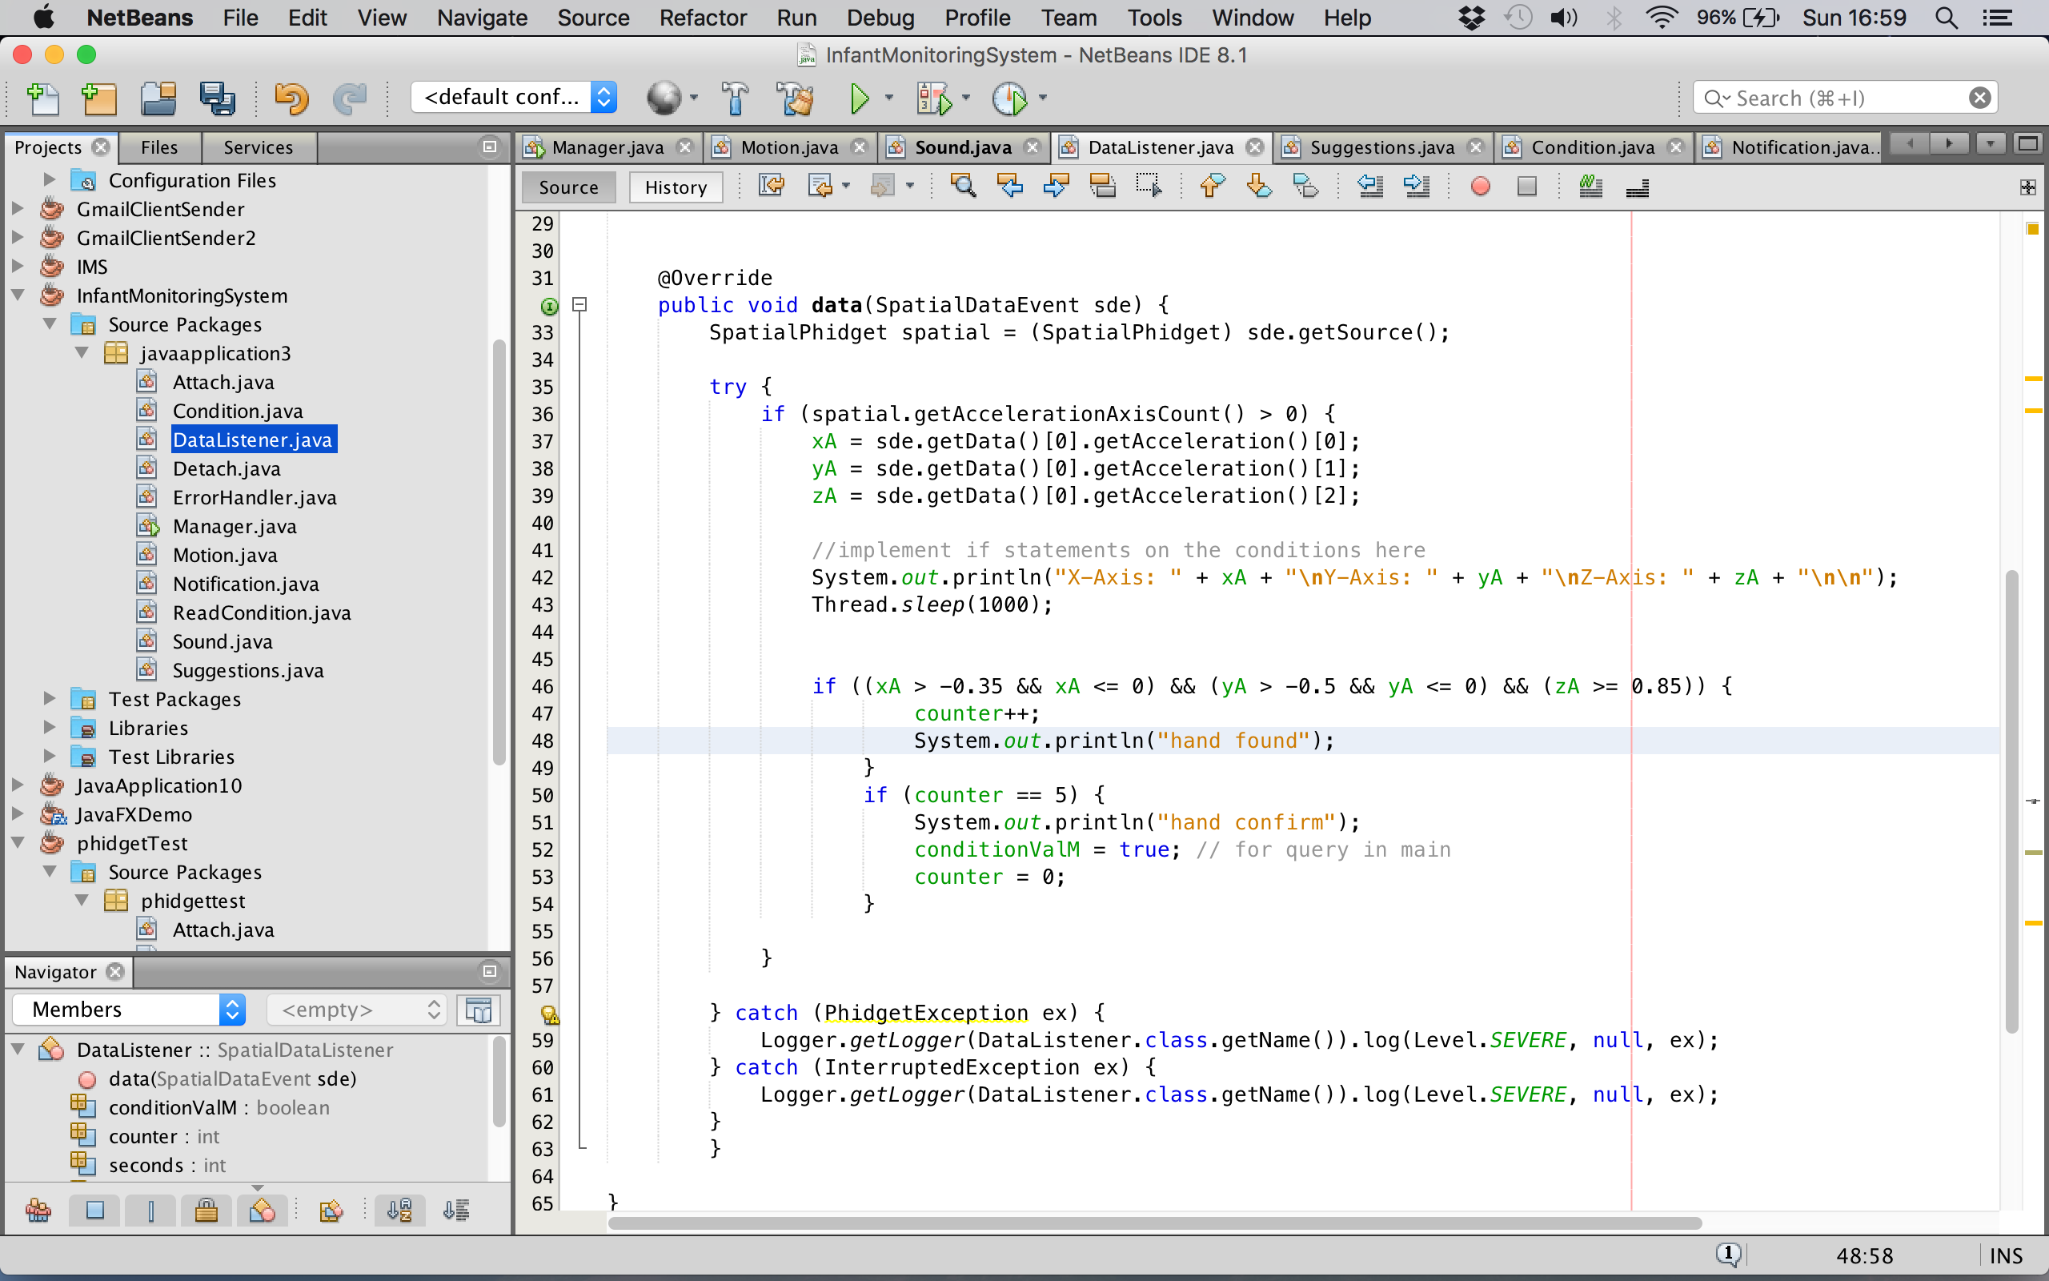

Figure (Motion Condition checking process)

Figure (26) displays multiple checks for the motion condition to be triggered, as the hand found condition must be met five times before it is confirmed as a definitive motion condition to be triggered.

The suggestion class contains an array of strings holding suggestions of hunger in different positions, which are printed by the notification process once the real time data has been processed.

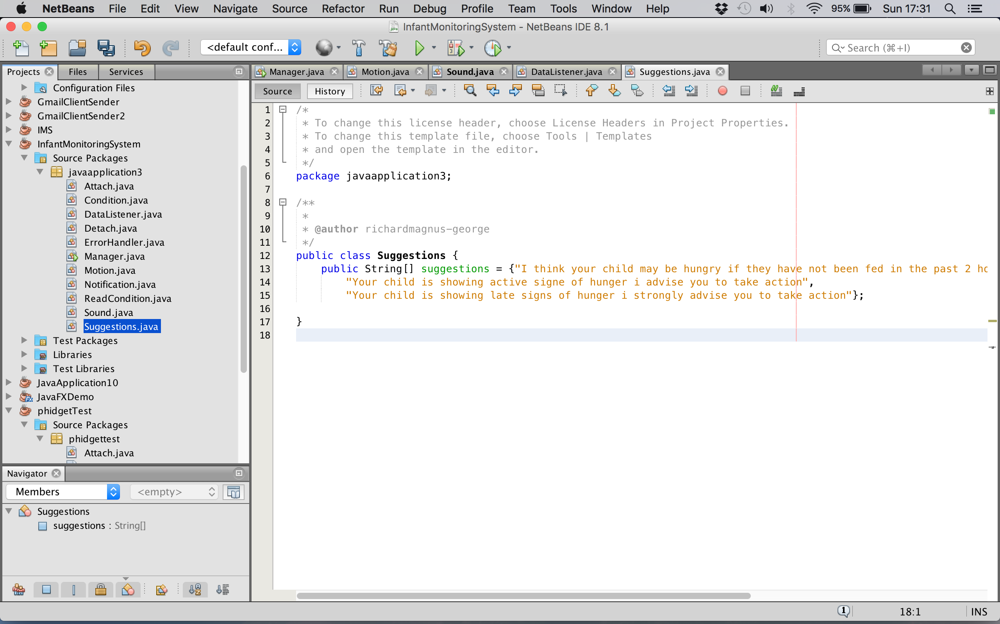

Figure (Suggestion class)

Figure (27) displays the suggestion class with an array of the possible suggestions for conditions met that will be sent in an email.

Test Data Processing process – In order to test the data processing process, a test run of the system using both sensors being run simultaneously was conducted. To determine weather the test was a success or not the “system.out.println” method was used for the relevant suggestion of action to be printed to the console. Due to the test being a success the console has printed out the relevant conditions associated with the condition triggered.

**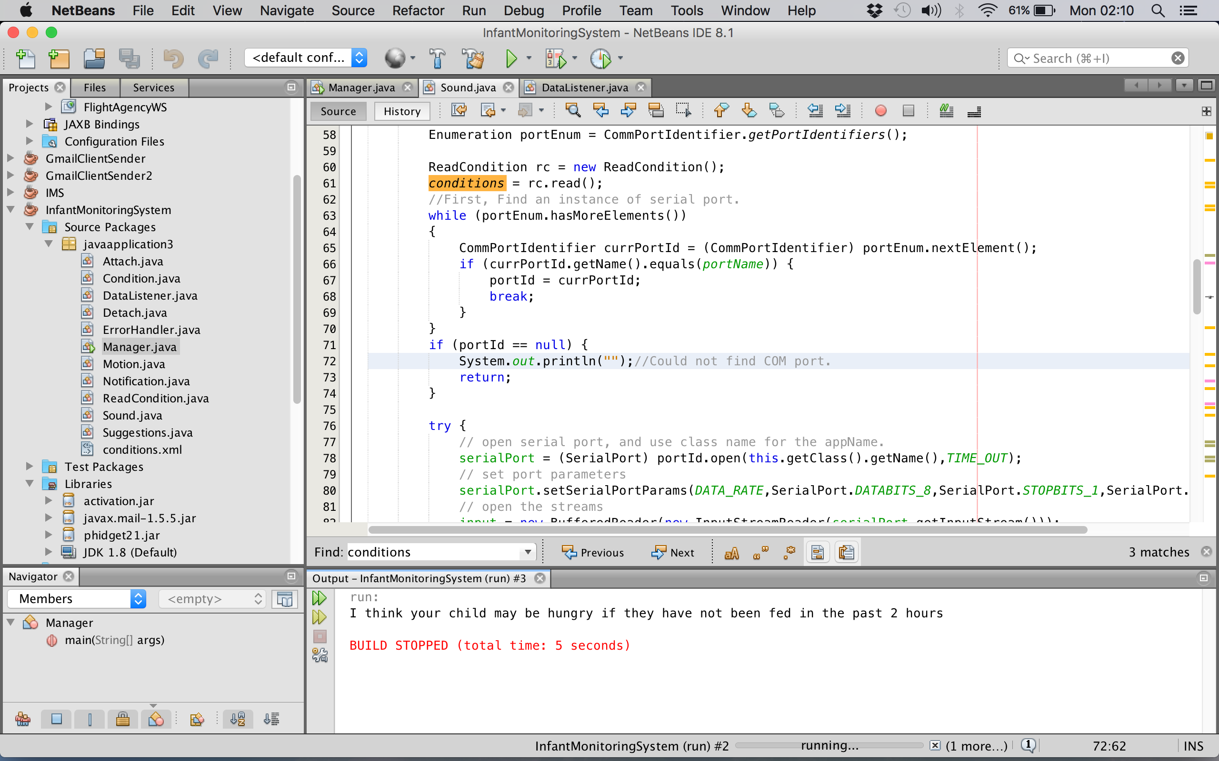**

Figure (Data Processing Test)

Figure (28) displays the early hunger indication suggestion printed out in the Netbeans console, meaning the test was a success.

## Setup notification

Notification – The notification process of the system is the final key process, as this is the process that actually alerts carers with suggestions of action completing the system. This process makes use of the Gmail RESTful service to make the notification process possible.

However, in order to use the Gmail RESTful service the javamail library and the java activation framework where both required for using the required functionality and frameworks.

To see further elaboration on RESTful services see (**3.2 Proposed Idea, RESTful** **API’s**)

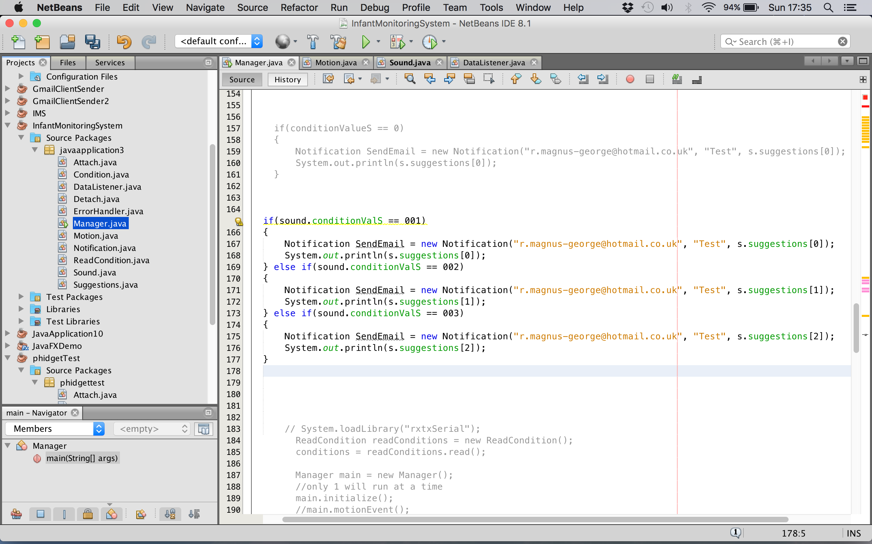

Figure (Notification method & Suggestion call)

Figure (29) displays how the notification method and the suggestions array from the suggestion class intervene to be able to send emails of relevant suggestions of action to carers.

Test Notification process – To test the notification process to ensure that it worked a Gmail account was created in order to send emails using this service, another email account from another email provider was created to be the recipient of the email. An email was then sent from the Gmail email account to the recipient and the message arrived in the recipient’s inbox, proving the test to be a success.

**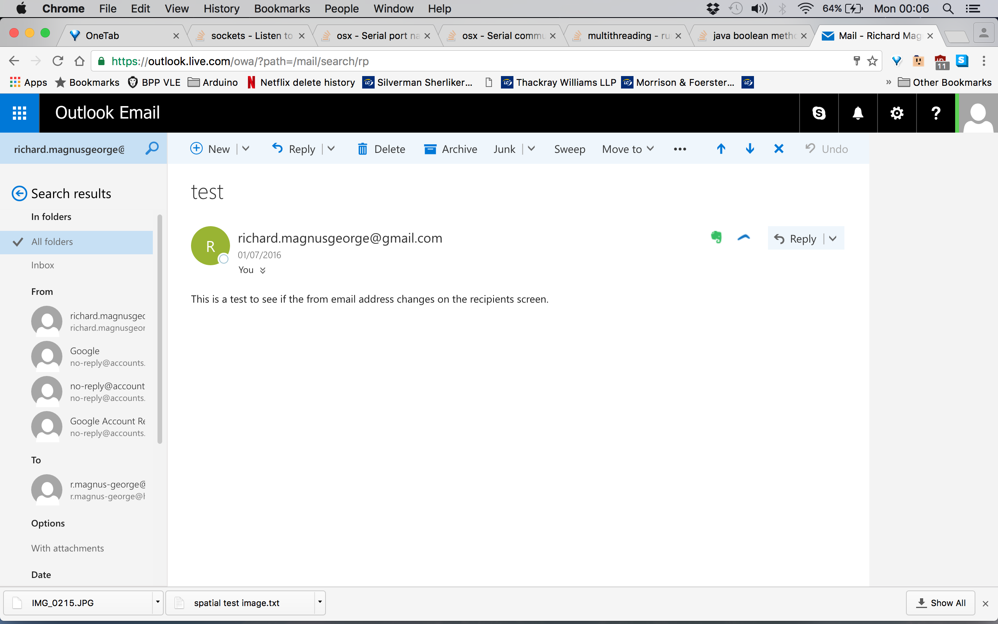**

Figure (Test Email)

Figure (30) shows an email coming from the Gmail account confirming that the test email has arrived to the intended recipient.

## Manager

The manager is responsible for creating two threads, one for capturing frequency of sound and the other for capturing motion. The reason why threads where created was because the system required both sensors to be able to run concurrently.

The manager is also responsible for sending suggestions through the notification process. This is done by the manager listening for the return values of the threads and based on this, the manager then calls the notification process assigning it a message called from the suggestions class.

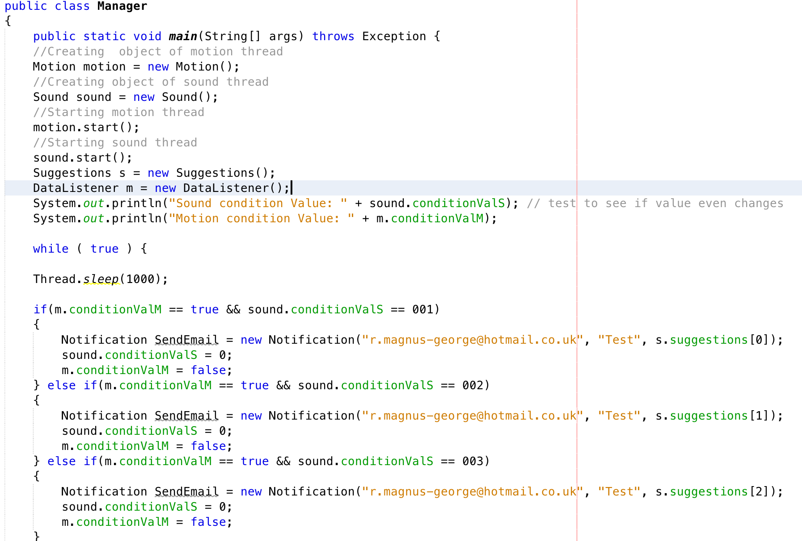

Figure (Manager class)

Figure (10) shows the manager class creating a motion and sound thread and calling both run methods to run both threads concurrently. It also displays the process of calling the notification method assigning it a suggestion depending on what return values are given from both threads.

## Summary

Finally, a variety of techniques and technologies have been implemented and integrated to produce a systematic solution addressing the issues at hand.

Multiple test were conducted when implementation milestones where reached, to ensure that functional requirements have been achieved in order to progress. Using the RUP life cycle methodology helped up hold high quality and higher chance of success rate as this methodology also adapted to late changes during different stages of the project.

This chapter addresses using multiple sensors to be able to capture minor sound and motion from infants. It also addresses the use of microcontrollers and serial communication to listen to real-time data. In addition to this it also elaborates on the use of RESTful services to implement the notification process.

The following chapter will consist of a detailed analysis and discussion of whether the initial aims & objectives have been achieved by implementing the proposed solution to address the issues at hand.



RESULTS / DISCUSSION

## Introduction

The main purpose of the system proves the hypothesis of whether small-scale sound and motion can give a prediction for infants hunger, making infant parenting easier.

All of the initial features discussed in Chapter 3 have been implemented and all the functionalities are fully functional. A variety of test where conducted on the on the system to determine the systems precision and accuracy, which will be discussed in detail in this chapter with elaboration on the test and their outcomes.

## Testing

### Testing environment

All undertaken test where conducted on the machine used for development. This machine was a MacBook laptop with a 2.6 GHz i5 Intel processor.

The main server was developed and installed on this dedicated laptop. This included all the server’s functionality and also the code used for the Phidget spatial accelerometer.

Tests where conducted in quiet environments to eliminate the factor of interfering sound. In addition to this all test using sensors especially the accelerometer, where conducted mimicking the positioning of an infant in resting position to represent an infant in their cot.

### Black Box Testing

A series of black box tests were conducted, in order to check if required functionality of the system that where stated in Chapter 3’s functional requirements where present and fully achieved. Using the black box method of testing, allowed results to be produced on unbiased circumstances, as the tester has no knowledge of the systems operation and only having knowledge of what the expected outcomes should be.

A test plan was put together to record results of the tests conducted by the tester, to determine what functionality was successfully implemented. See table **(**3**)** for the completed test plan. All test conducted in the test plan where successfully passed showing the functional requirements where all met.

Table (Black Box Test Plan)

|  |  |  |  |  |
| --- | --- | --- | --- | --- |
| Test No# | Test Description | Expected Outcome | Actual Outcome | Test Result |
| 1 | Test if the system is capable of reading sound & motion data from the sensors concurrently. | When the system is running and sensors are connected both the frequency of sound and values of the 3 axes motion of should be displayed in the output console. | When the system is running and sensors are connected the frequency of sound and the 3 axes of motion are both displayed in the output console. | Passed |
| 2 | Test if the system is capable of reading data from the sensors in real time. | When the systems running and change in motion or sound should be reflected on the output console. | When the system was run all changes of motion or sound was reflected on the output console. | Passed |
| 3 | Test if the system is capable of processing data from the sensors. | The system will print out the average value of the results picked up from the microphone or print out a message confirming the motion conditions been triggered. | The system printed out to the console the average value picked up from the microphone sensor and a confirmation of the motion condition being triggered. | Passed |
| 4 | Test if the system capable of querying suggestion of action. | When different combinations of conditions are triggered, different suggestions should be sent. | Multiple combinations of conditions where met and suggestions of action where used in the notification process. | Passed |
| 5 | Test if the system is capable of notifying users when certain thresholds of conditions are met. | The condition triggering values should be printed out to the console and if two conditions are met the notification should be sent. | The condition triggering values were printed out to the console and if two conditions are met an email notification was sent. | Passed |

### Further Testing

A variety of further test on individual components of the system and of the system as a whole where conducted in order to help determine whether the system successfully served its purpose and if so to what degree of accuracy.

Not all of the tests were actually necessary to be conducted in this chapter, as some test where undertaken through out the development process of the project due the nature of the RUP methodology. This can be seen in Chapter 4.

**Phidget Spatial Accelerometer Test** – In order to test out the accuracy of the spatial 0/0/3 accelerometer, a test was conducted by checking the accuracy of the co-ordinates by seeing if there has been a difference in the change of outputted x, y and z axes when the accelerometer has been moved horizontally from the mouth region to the left and right just above the shoulder areas. The accelerometer was attached to the testers arm to replicate a wearable sensor, as this is what would be ideal to obtain accurate results.

As a result, the y and z-axis practically stayed the same every time but the x-axis value was the only value that drastically changed, as this is the axis that represents horizontal movement. This test was carried out multiple times to accurate definitive results. The averaged results of this test are displayed below in table (4).

Table (Averaged Spatial Accelerometer Test Results)

|  |  |  |  |
| --- | --- | --- | --- |
| **Hand to Mouth direction** | **X-Axis Value** | **Y-Axis Value** | **Z-Axis Value** |
| **Furthest** **Left** | -0.4 | -0.67 | 0.72 |
| **Furthest** **Right** | 0.23 | -0.67 | 0.65 |
| **Centre** | 0.0 | -0.73 | 0.71 |

The results from this test have proven to be a success, as the accuracy of the accelerometer was justified to be accurately reliable.

As an extension, a secondary test was also conducted to see whether some of the values from the previous test where sufficient enough to be used as thresholds for the motion condition. This test was conducted by setting the thresholds of the condition to the values returned in the previous test. By mimicking the motions that are likely to trigger the condition, it was possible to return a result of true if the accelerometer entered the region of the thresholds.

This test was also conducted multiple times providing promising results. Table **(**5**)** displays the motions of movement that where made in comparison to the results obtained of whether the condition was met or not.

Table (Spatial Accelerometer Condition Test Results)

|  |  |  |  |
| --- | --- | --- | --- |
| **Hand to Mouth direction** | **Number of attempts** | **Success rate** | **Failure rate** |
| **Furthest** **Left** | 10 | 9/10 | 1/10 |
| **Furthest** **Right** | 10 | 8/10 | 2/10 |
| **Centre** | 10 | 10/10 | 0/10 |

Overall the accelerometer condition test proved to have a 90% success rate, proving this method of capturing motion to be very reliable.

**Microphone Sensor Test** – In order to test the accuracy of the microphone sensor, a test was conducted by using the microphone to listen to the frequencies of early, active and late infant cries from various distances to test the quality and accuracy of the microphone.

The microphone was tested being next to the speaker, 20 cm and 40 cm away to represent how far away the infant can be from the microphone when in their cot. This method of testing the microphone was also chosen due to the fact that it takes distance, quality/sensitivity of the microphone and inference into consideration, as it will have an impact on data readings. This test was also conducted multiple times to obtain definitive results.

The results from this test show that when the microphone is right next to the speaker the average frequency is around 500hz. From around 20 cm the average of frequency picked up is around 230hz. From around 40cm the average frequency picked up is around 150hz.

These values show they where a lot lower in comparison to the frequencies produced in Audacity, this is because Audacity doesn’t take interference, distance and the quality/sensitivity on the microphone into consideration.

A secondary test was also conducted to determine if the values obtained from the previous test where valid enough to use as thresholds for the sound conditions. This test was conducted by setting the conditions threshold to the values obtained in the previous test and recordings of different level of hunger cries from infants where played to see if the correct conditions where triggered. This test was carried out a numerous amount of times in order to obtain definitive results.

Table (6) displays the results of this test, providing amicable results.

Table (Microphone Sensor Condition Test Results)

|  |  |  |  |
| --- | --- | --- | --- |
| **Level of cries** | **Number of attempts** | **Success rate** | **Failure rate** |
| **Pre-cries** | 10 | 8/10 | 2/10 |
| **Active cries** | 10 | 8/10 | 2/10 |
| **Late cries** | 10 | 8/10 | 2/10 |

In conclusion, although the test had a 20% fail rate, the microphone condition test proved to have an 80% success rate, proving this method of capturing sound was still very reliable.

**System Test** – A final test was conducted to conclude whether the system had proven to be a success and fit for its purpose.

The test was conducted by playing the different levels of hunger audio clips to the microphone sensor while the tester mimicked the resting position of an infant with the accelerometer attached to their arm to represent a wearable sensor to see the outcome of when the motion and a sound condition is met.

The expected outcomes were for the notification process to be called using the suggestion querying process to retrieve and send to the intended recipient, the correct suggestion for the conditions met. The results where then recorded for detailed analysis. This test was undertaken a numerous amount of times to obtain reliable results.

Table (7) displays the results from the overall system test, producing detailed results.

Table (Overall System Test Results (Pre-Cries))

|  |  |  |  |  |  |  |
| --- | --- | --- | --- | --- | --- | --- |
| **Pre-cries Condition** | **Active cries Condition** | **Late cries Condition** | **Motion Condition** | **Notification process called** | **Correct suggestion selected** | **Pass or fail** |
| True | False | False | True | True | True | Pass |
| True | False | False | True | True | True | Pass |
| False | True | False | True | True | False | Fail |
| True | False | False | True | True | True | Pass |
| True | False | False | True | True | True | Pass |
| True | False | False | True | True | True | Pass |

The results produced from pre-cries overall system test had proved to have an 80% success rate. However, the test also had a 20% rate of failure. This was due to lack of accuracy in the pre-cry and active-cry thresholds.

Table (Overall System Test Results (Active-Cries))

|  |  |  |  |  |  |  |
| --- | --- | --- | --- | --- | --- | --- |
| **Pre-cries Condition** | **Active cries Condition** | **Late cries Condition** | **Motion Condition** | **Notification process called** | **Correct suggestion selected** | **Pass or fail** |
| True | False | False | True | True | False | Fail |
| False | True | False | False | False | False | Fail |
| False | True | False | True | True | True | Pass |
| False | True | False | True | True | True | Pass |
| False | True | False | True | True | True | Pass |
| False | True | False | True | True | True | Pass |

The results produced from active-cries overall system test had proved to have a 60% success rate. However, the test also had a large failure rate of 40%. This was due to lack of accuracy in the pre-cry and active-cry thresholds once again. This was also due to the lack of accuracy in the motion detection threshold.

Table (Overall System Test Results (Late-Cries))

|  |  |  |  |  |  |  |
| --- | --- | --- | --- | --- | --- | --- |
| **Pre-cries Condition** | **Active cries Condition** | **Late cries Condition** | **Motion Condition** | **Notification process called** | **Correct suggestion selected** | **Pass or fail** |
| False | False | True | True | True | True | Pass |
| False | False | True | True | True | True | Pass |
| False | False | True | True | True | True | Pass |
| False | False | True | True | True | True | Pass |
| False | True | False | True | True | False | Fail |
| False | False | True | True | True | True | Pass |

The results produced from late-cries overall system test had proved to have an 80% success rate. However, the test also had a 20% rate of failure. This was due to lack of accuracy in the active-cry and late-cry thresholds.

As an overall result, the system test had an accumulative success rate of 73% proving to be reliable around ¾ of the time.

## Discussion

By using multiple methods of testing, gave the ability to establish what requirements were met in Chapter 3. Using the Black Box testing method made it possible to prove that the all the functional requirements where met and the system was fully functional.

On the other hand, after conducting several other individual component tests and whole system tests, the accelerometer proved to be accurate 90% of the time, the microphone proved to be accurate 80% of the time and as an overall system proved to be fit for its purpose 73% of the time. Some of these results appeared to be realistic but also disappointing, as the accuracy of the system could be improved to increase chances of proving the initial hypothesis of whether it is possible to get predictions of hunger for an infant using small-scale movement and noises.

In addition, one of the reasons that accuracy of the overall system was lower than expected was due to identifying and excluding all other noises apart from the infant cries. This could have been implemented by identifying and excluding all sounds without consistent frequency patterns if time constraints were not an issue, as Bhagatpatil stated all cries have a timed frequency pattern (Bhagatpatil, 2014). However, this will be discussed further in Chapter 6.

## Summary

The implementation of key components of the system and the system as a whole was thoroughly tested, showing that all requirements where implemented. However, the test also brought to realisation of the fact that the system was not accurate as intended.

Although the system was not 100% accurate which slightly compromised its reliability to prove the hypothesis, the system was still fully functional.

This chapter also helped to discover issues, which required improvement. These areas will be elaborated on in Chapter 6.



CONCLUSIONS / FUTURE WORK

## Conclusion

The purpose of this project was to create a systematic solution, which aims to prevent behaviour disorder later in infants lives and to simplify the job of infant parenting by identifying early clues of hunger.

The end product produced from this project was fully functional and operational, as all initial requirements and components of the system were implemented. However, the system lacked accuracy, which slightly hindered the validity of its results. Although the system had its drawbacks, it still proved the hypothesis to be possible resulting in a success.

## Future work

All of the set requirements and intended implementations where implemented in the project. Any improvements of functionality that could be done to improve the system and any new functionality that could be used to also better the system will be discussed in this chapter.

### Using the spatial 3/3/3 instead of 0/0/3

Currently the accelerometer being used is the Phidget spatial 0/0/3. This accelerometer is limited to only being able to sense and give information of direction of acceleration.

If a spatial 3/3/3 accelerometer was accessible, it would have been possible obtain better accuracy as it has gyroscope capabilities to help aid in capturing motion from infants. This accelerometer could be opted as a future improvement.

### Use of Omni Microphone instead of directional

Currently a directional microphone sensor is being used to pick up noises from the infant resting it the cot. This means that the microphone has to be pointing in the direction of where the noise is coming from and the noise must be projected in the direction of the microphone to obtain the best results, which is obviously not as ideally practical.

As a future improvement, multiple microphones can be placed in the infant’s cot to be able to have multiple readings of sound in order to get better averaged results or an Omni directional microphone could be used, which allows the microphone to pick up sound from multiple angles making the microphone more productive and reliable.

### Video recognition software & connect sensor

Currently to obtain the early motion hunger clues, an accelerometer is being used. However, this method of checking whether a infant has put their hand in or on their mouth works to an extent but is not the best method to establish this as it is not 100% accurate as using other methods like video recognition software.

This could be implemented as an improvement of functionality by putting a wrist band or a mitten of a distinctive colour on the infants hand for it to be distinctively identified by the connect sensor, which will be able to identify exactly when the mitten or wrist band has entered the region of the infants mouth. However, implementing this method deemed to be quite complex and unrealistically achievable in the project scope due time constraints. Using this method of obtaining early motion hunger clues would not only be most ideal but would also increase the accuracy of the overall system.

In addition to this, this method of monitoring motion would have, opened an avenue to identifying secondary late hunger clues. With this technology it would have been possible to monitor infants head movements to see whether o see if they moving their head franticly out of frustration. This would have also increased not only the chances of identifying late hunger clues but the accuracy of the system as a whole.

### Extracting all other sound apart from cries

As a future improvement, an extraction method of all other souses apart from the infant’s cries could have been implemented into the microphone sensors Arduino script.

This would be implemented by identifying continuous frequency patterns as discussed in Chapter 5 (**5.4 Discussion**). Ultimately would increase the accuracy of the system proving it to be more reliable.

### Having sensors in one unit

Initially the idea was implement all sensors into one unit and to transmit data readings to the server wirelessly, using Bluetooth of WI-FI.

Due to time constraints and lack of resources, currently one of the sensors are connected to a micro controller via jumper wires and the micro controller was connected to the laptop via USB.

In addition to this, the second sensor was also directly connected to the laptop via a USB wire, this was not practical as wires being in the infants cot can be hazardous and it was also not ideal to have to have the server (Laptop) so close to the cot.

As unfinished implementations and as a future improvement, all sensors would be implemented into one unit to transmit real-time data readings wirelessly as there are existing microcontrollers and sensors with these capabilities. Ideally this would be implemented into a wearable sensor wristband for simplicity of attachment/detachment. It will be out of the infant’s way reducing chance of irritation.

### Notification process

Currently the notification process is made by using the Gmail RESTful service to send emails to carers notifying them of suggestion.

On the other hand, as the user interface was not a main focus in the project it was not ideal for a dedicated application be implemented just to show means of notification. However, use of a dedicated application could be a very useful feature as notification through applications can be a lot more alerting also allowing users to distinctively identify what a notification received is for.

Application notifications may have its own dedicated vibration, LED flashing colour, notification alerting sound and also its own dedicated software icon that will pop up on your mobile devices home screen possibly also displaying the suggestion.

## PSEL Issues

It is important to take into consideration the possible professional, social, ethical and legal issues, which should be taken into account through the life cycle of the project.

### Professional

A professional issue that would have to be taken into consideration is the issue of having to proficiently monitor quality control in the process of development of the system. This is because an infant is an end user of this system that can be considered vulnerable to the quality of materials used for the wearable sensors to protect against skin irritation and quality of the connection of the circuit to absorb any potential electric shocks.

In addition to this, there would also be a professional issue that would have to be taken into consideration of clear and precise cleaning instructions being provided of how to wash the wearable sensors, as there is a danger of electronics consuming water and infants are bound to mess their clothes due to their tendencies of vomiting and producing excessive saliva.

### Social

A social issue that will have to be taken into consideration is the issue of the systems conditions being triggered from inaccurate values and waking up carers at unsocial hours of the night for mistaken triggered conditions. However this issue comes down to the accuracy of the system being improved.

### Ethical

A ethical issues that will have to be taken into consideration, is the issue of ensuring that the components utilised in the system do not use an excessive amount of energy and only consume the amount necessary for the system to be fully functional. Taking action on this issue will allow the product to be a viable eco-friendly system.

### Legal

Legal issue that will also have to be taken into consideration, is the issue of having to adhere to and pass the 2006/95/EC, the Low Voltage Directive safety standards for it to be legal for infants to wear wearable sensors, as this could lead to skin irritation or possibly electric shocks as electronic devices are being used.

In addition to this, another legal that that would have to be strongly considered is the Data Act Protection Law. This is due to using users email credentials for the notification process. The email addresses and passwords may have to have some sort of encryption method applied to them to uphold integrity and confidentiality.

References

BBC News, (1999). Health Cot death monitor warning. [online] Available at:<http://news.bbc.co.uk/1/hi/health/321473.stm> [Accessed 7 Feb. 2016].

Onion, Rebecca. (2013). ["The World's First Baby Monitor: Zenith's 1937 "Radio Nurse""](http://www.slate.com/blogs/the_vault/2013/02/07/zenith_s_radio_nurse_designed_by_isamu_noguchi_was_the_world_s_first_baby.html). [*Slate (magazine)*](https://en.wikipedia.org/wiki/Slate_(magazine)). [The Slate Group](https://en.wikipedia.org/wiki/The_Slate_Group). [Online] Available at: <http://www.slate.com/blogs/the_vault/2013/02/07/zenith_s_radio_nurse_designed_by_isamu_noguchi_was_the_world_s_first_baby.html> [Accessed 7 Feb. 2016].

Vam.ac.uk, (2016). ‘Radio Nurse’ baby monitor by Isamu Noguchi, 1937 [Online] Available at: <http://www.vam.ac.uk/content/articles/r/isamu-noguchi-radio-nurse-baby-monitor/> [Accessed 7 Feb. 2016].

Slate.com, (2013). The World’s First Baby Monitor: Zenith’s 1973 “Radio Nurse” [Online] Available at: <http://www.slate.com/blogs/the_vault/2013/02/07/zenith_s_radio_nurse_designed_by_isamu_noguchi_was_the_world_s_first_baby.html> [Accessed 8 Feb. 2016].

Wiley,

PCMag UK, (2016). Best Baby Monitors of 2015. [Online] Available at: <http://uk.pcmag.com/webcams-products/34485/guide/the-best-baby-monitors-of-2015> [Accessed 8 Feb. 2016].

Babycentre.co.uk, (2014). Buying a Baby Monitor. [Online] Available at: <http://www.babycentre.co.uk/a569840/buying-a-baby-monitor> [Accessed 9 Feb. 2016].

Time.com, (2014). Don’t Count on Smart Baby Monitors To Prevent SIDS. [Online] Available at: <http://time.com/3593482/sids-baby-monitors/> [Accessed 9 Feb. 2016].

Bazian, NHS, (). Crying babies and later behavioural problems. [Online] Available at: <http://www.nhs.uk/news/2011/04April/Pages/crying-babies-and-later-behavioural-problems.aspx> [Accessed 9 Feb. 2016].

“Zinganshim E.G”, “Numerov M. A” and “Vygolov S. A”, (2010). UWB BABY MONITOR. [PDF] Available at: <https://www.researchgate.net/publication/224185025_UWB_Baby_Monitor> [Accessed 11 Feb. 2016].

Business Wire, (2014). KODAK Baby Monitoring System by Seedonk Selected As 2015 CES Innovation Awards Honouree. [Online] Available at: <http://search.proquest.com/docview/1638899362?accountid=14693&rfr_id=info%3Axri%2Fsid%3Aprimo> [Accessed 11 Feb. 2016].

Kodak Video Monitors, (2014). KODAK VIDEO MONITOR CFH-BVA10. [Online] Available at: <https://cdn.shopify.com/s/files/1/1356/6983/files/Kodak_BVA10_Sell_Sheet.pdf?12542212087157169517> [Accessed 14 Feb. 2016].

Pricilla Dunstan, (2012). Calm The Crying: Using Dunstan Baby Language. [Book] Available at: <https://books.google.co.uk/books?hl=en&lr=&id=rhS0FmUddaQC&oi=fnd&pg=PT10&dq=priscilla+dunstan&ots=ks0pct_po1&sig=PBB448yen_Hq9ft9gKHxDdEIAhQ#v=onepage&q=priscilla%20dunstan&f=false> [Accessed…].

Kellymom.com, (2015). Hunger Cues – When do I feed a baby? [Online] Available at: <http://kellymom.com/bf/normal/hunger-cues/> [Accessed 14 Feb. 2016].

Arduino.cc, (2016). GETTING STARTED | FOUNDATION > Introduction. [Online] Available at: <https://www.arduino.cc/en/Guide/Introduction> [Accessed 14 Feb. 2016].

Digital Trends, (2015). ARDUINO VS. RASPBERRY PI: MORTAL ENEMIRES, OR BEST FRIENDS? [Online] Available at: <http://www.digitaltrends.com/computing/arduino-vs-raspberry-pi/> [Accessed 15 Feb. 2016].

Forumallaboutcircuits.com, (2012). RAM usage/need in micro controllers. [Online] Available at: <http://forum.allaboutcircuits.com/threads/ram-usage-need-in-microcontrollers.73039/> [Accessed 15 Feb. 2016].

Jostein Svendsli, (2003). Atmel’s Self-Programming Flash Microcontrollers. [PDF] Available at: <http://www.atmel.com/Images/doc2464.pdf> [Accessed 18 Feb. 2016].

Steve Heat, (2003). Embedded Systems Design: Second Edition. [Book] Available at:<https://books.google.co.uk/books?id=BjNZXwH7HlkC&pg=PA11&redir_esc=y#v=onepage&q&f=false> [Accessed 18 Feb. 2016].

Phidgets.com, (2012). 1044\_0 – PhidgetSpatial Precision 3/3/3 High Resolution. [Online] Available at: <http://www.phidgets.com/products.php?product_id=1044>[Accessed 19 Feb. 2016].

NHS Choices, (2015). Colic. [Online] Available at: <http://www.nhs.uk/conditions/Colic/Pages/Introduction.aspx> [Accessed 21 Feb. 2016].

Garrett Hamilton–Smith, Raihan Khondker, and Will Norris, (2012). Infrared Proximity Sensor. [Online] Available at: <http://www.g9toengineering.com/AllSaints/infraredproximity.htm> [Accessed 21 Feb. 2016].

Techopedia.com, (2016). User Datagram Protocol (UDP). [Online] Available at: <https://www.techopedia.com/definition/13460/user-datagram-protocol-udp> [Accessed 24 Feb. 2016].

Jguru.com, (2012). What is UDP and how does it work? [Online] Available at: <http://www.jguru.com/faq/view.jsp?EID=9472> [Accessed 24 Feb. 2016].

Jguru.com, (2012). What is TCP and how does it work? [Online] Available at: <http://www.jguru.com/faq/view.jsp?EID=14663> [Accessed 1 Apr. 2016].

Playground.arduino.cc, (2016). Arduino and Java. [Online] Available at: <http://playground.arduino.cc/Interfacing/Java> [Accessed 1 Apr. 2016].

Readwrite.com, (2014). Arduino Vs Raspberry Pi: Which Is The Right DIY Platform For You? [Online] Available at: <http://readwrite.com/2014/05/07/arduino-vs-raspberry-pi-projects-diy-platform/> [Accessed 2 Apr. 2016].

Margaret Rouse, (2014). RESTful API. [Online] Available at: <http://searchcloudstorage.techtarget.com/definition/RESTful-API> [Accessed 2 Apr. 2016].

Textlocal.com, (2016). Text API. [Online] Available at: <http://www.textlocal.com/mobile-marketing-services> [Accessed 4 Apr. 2016].

MSOutlook.info, (2016). Increase the maximum attachment size limit. [Online] Available at: <https://www.msoutlook.info/question/increase-maximum-attachment-size-limit> [Accessed 4 Apr. 2016].

Support.microsoft.com, (2016). “Attachment size exceeds the allowable limit” error when you add a large attachment to email message in Outlook. [Online] Available at: <https://support.microsoft.com/en-gb/kb/2813269> [Accessed 4 Apr. 2016].

Optimus Information, (2016). Traditional vs Agile Software Development. [Online] Available at: <http://www.optimusinfo.com/traditional-vs-agile-software-development/> [Accessed 5 Apr. 2016].

IstqbeExamCertification.com, (2016). What is Waterfall model-advantages, disadvantages and when to use it? [Online] Available at: <http://istqbexamcertification.com/what-is-waterfall-model-advantages-disadvantages-and-when-to-use-it/> [Accessed 5 Apr. 2016].

Daria Kelly Uhlig, (2016). Advantages and Disadvantages of the Scrum Project Management Methodology. [Online] Available at: <http://smallbusiness.chron.com/advantages-disadvantages-scrum-project-management-methodology-36099.html> [Accessed 5 Apr. 2016].

MyPMExpert.com, (2009). The Advantages and Disadvantages/ Best Practices of RUP Software Development. [Online] Available at: <http://www.my-project-management-expert.com/the-advantages-and-disadvantages-of-rup-software-development.html> [Accessed 6 Apr. 2016].

Sunfounder.com, (2016). Lesson 25 Microphone Sensor. [Online] Available at: <https://www.sunfounder.com/learn/sensor_kit_v1_for_Arduino/lesson-25-microphone-sensor-sensor-kit-v1-for-arduino.html> [Accessed 6 Apr. 2016].

Miss Varsharani V Bhagatpatil, Prof.V.M.Sardar, (2014). International Journal of Scientific & Engineering Research, Volume 5. [PDF] Available at: <http://www.ijser.org/researchpaper%5CAn-Automatic-Infants-Cry-Detection-Using-Linear-Frequency.pdf> [Accessed 6 Apr. 2016].

Bibliography

BBC News, (1999). Health Cot death monitor warning. [online] Available at:<http://news.bbc.co.uk/1/hi/health/321473.stm> [Accessed 7 Feb. 2016].

Onion, Rebecca. (2013). ["The World's First Baby Monitor: Zenith's 1937 "Radio Nurse""](http://www.slate.com/blogs/the_vault/2013/02/07/zenith_s_radio_nurse_designed_by_isamu_noguchi_was_the_world_s_first_baby.html). [*Slate (magazine)*](https://en.wikipedia.org/wiki/Slate_(magazine)). [The Slate Group](https://en.wikipedia.org/wiki/The_Slate_Group). [Online] Available at: <http://www.slate.com/blogs/the_vault/2013/02/07/zenith_s_radio_nurse_designed_by_isamu_noguchi_was_the_world_s_first_baby.html> [Accessed 7 Feb. 2016].

Bupa.co.uk, (2016). Antenatal care. [Online] Available at: <http://www.bupa.co.uk/health-information/directory/s/sids> [Accessed…].

Vam.ac.uk, (2016). ‘Radio Nurse’ baby monitor by Isamu Noguchi, 1937 [Online] Available at: <http://www.vam.ac.uk/content/articles/r/isamu-noguchi-radio-nurse-baby-monitor/> [Accessed 7 Feb. 2016].

Slate.com, (2013). The World’s First Baby Monitor: Zenith’s 1973 “Radio Nurse” [Online] Available at: <http://www.slate.com/blogs/the_vault/2013/02/07/zenith_s_radio_nurse_designed_by_isamu_noguchi_was_the_world_s_first_baby.html> [Accessed 8 Feb. 2016].

Wiley,

PCMag UK, (2016). Best Baby Monitors of 2015. [Online] Available at: <http://uk.pcmag.com/webcams-products/34485/guide/the-best-baby-monitors-of-2015> [Accessed 8 Feb. 2016].

Babycentre.co.uk, (2014). Buying a Baby Monitor. [Online] Available at: <http://www.babycentre.co.uk/a569840/buying-a-baby-monitor> [Accessed 9 Feb. 2016].

Time.com, (2014). Don’t Count on Smart Baby Monitors To Prevent SIDS. [Online] Available at: <http://time.com/3593482/sids-baby-monitors/> [Accessed 9 Feb. 2016].

Bazian, NHS, (). Crying babies and later behavioural problems. [Online] Available at: <http://www.nhs.uk/news/2011/04April/Pages/crying-babies-and-later-behavioural-problems.aspx> [Accessed 9 Feb. 2016].

“Zinganshim E.G”, “Numerov M. A” and “Vygolov S. A”, (2010). UWB BABY MONITOR. [PDF] Available at: <https://www.researchgate.net/publication/224185025_UWB_Baby_Monitor> [Accessed 11 Feb. 2016].

Business Wire, (2014). KODAK Baby Monitoring System by Seedonk Selected As 2015 CES Innovation Awards Honouree. [Online] Available at: <http://search.proquest.com/docview/1638899362?accountid=14693&rfr_id=info%3Axri%2Fsid%3Aprimo> [Accessed 11 Feb. 2016].

Kodak Video Monitors, (2014). KODAK VIDEO MONITOR CFH-BVA10. [Online] Available at: <https://cdn.shopify.com/s/files/1/1356/6983/files/Kodak_BVA10_Sell_Sheet.pdf?12542212087157169517> [Accessed 14 Feb. 2016].

Pricilla Dunstan, (2012). Calm The Crying: Using Dunstan Baby Language. [Book] Available at: <https://books.google.co.uk/books?hl=en&lr=&id=rhS0FmUddaQC&oi=fnd&pg=PT10&dq=priscilla+dunstan&ots=ks0pct_po1&sig=PBB448yen_Hq9ft9gKHxDdEIAhQ#v=onepage&q=priscilla%20dunstan&f=false> [Accessed…].

Kellymom.com, (2015). Hunger Cues – When do I feed a baby? [Online] Available at: <http://kellymom.com/bf/normal/hunger-cues/> [Accessed 14 Feb. 2016].

Arduino.cc, (2016). GETTING STARTED | FOUNDATION > Introduction. [Online] Available at: <https://www.arduino.cc/en/Guide/Introduction> [Accessed 14 Feb. 2016].

Digital Trends, (2015). ARDUINO VS. RASPBERRY PI: MORTAL ENEMIRES, OR BEST FRIENDS? [Online] Available at: <http://www.digitaltrends.com/computing/arduino-vs-raspberry-pi/> [Accessed 15 Feb. 2016].

Forumallaboutcircuits.com, (2012). RAM usage/need in micro controllers. [Online] Available at: <http://forum.allaboutcircuits.com/threads/ram-usage-need-in-microcontrollers.73039/> [Accessed 15 Feb. 2016].

Jostein Svendsli, (2003). Atmel’s Self-Programming Flash Microcontrollers. [PDF] Available at: <http://www.atmel.com/Images/doc2464.pdf> [Accessed 18 Feb. 2016].

Steve Heat, (2003). Embedded Systems Design: Second Edition. [Book] Available at:<https://books.google.co.uk/books?id=BjNZXwH7HlkC&pg=PA11&redir_esc=y#v=onepage&q&f=false> [Accessed 18 Feb. 2016].

Phidgets.com, (2012). 1044\_0 – PhidgetSpatial Precision 3/3/3 High Resolution. [Online] Available at: <http://www.phidgets.com/products.php?product_id=1044>[Accessed 19 Feb. 2016].

NHS Choices, (2015). Colic. [Online] Available at: <http://www.nhs.uk/conditions/Colic/Pages/Introduction.aspx> [Accessed 21 Feb. 2016].

Garrett Hamilton–Smith, Raihan Khondker, and Will Norris, (2012). Infrared Proximity Sensor. [Online] Available at: <http://www.g9toengineering.com/AllSaints/infraredproximity.htm> [Accessed 21 Feb. 2016].

Techopedia.com, (2016). User Datagram Protocol (UDP). [Online] Available at: <https://www.techopedia.com/definition/13460/user-datagram-protocol-udp> [Accessed 24 Feb. 2016].

Jguru.com, (2012). What is UDP and how does it work? [Online] Available at: <http://www.jguru.com/faq/view.jsp?EID=9472> [Accessed 24 Feb. 2016].

Jguru.com, (2012). What is TCP and how does it work? [Online] Available at: <http://www.jguru.com/faq/view.jsp?EID=14663> [Accessed 1 Apr. 2016].

Playground.arduino.cc, (2016). Arduino and Java. [Online] Available at: <http://playground.arduino.cc/Interfacing/Java> [Accessed 1 Apr. 2016].

Readwrite.com, (2014). Arduino Vs Raspberry Pi: Which Is The Right DIY Platform For You? [Online] Available at: <http://readwrite.com/2014/05/07/arduino-vs-raspberry-pi-projects-diy-platform/> [Accessed 2 Apr. 2016].

Margaret Rouse, (2014). RESTful API. [Online] Available at: <http://searchcloudstorage.techtarget.com/definition/RESTful-API> [Accessed 2 Apr. 2016].

Textlocal.com, (2016). Text API. [Online] Available at: <http://www.textlocal.com/mobile-marketing-services> [Accessed 4 Apr. 2016].

MSOutlook.info, (2016). Increase the maximum attachment size limit. [Online] Available at: <https://www.msoutlook.info/question/increase-maximum-attachment-size-limit> [Accessed 4 Apr. 2016].

Support.microsoft.com, (2016). “Attachment size exceeds the allowable limit” error when you add a large attachment to email message in Outlook. [Online] Available at: <https://support.microsoft.com/en-gb/kb/2813269> [Accessed 4 Apr. 2016].

Optimus Information, (2016). Traditional vs Agile Software Development. [Online] Available at: <http://www.optimusinfo.com/traditional-vs-agile-software-development/> [Accessed 5 Apr. 2016].

IstqbeExamCertification.com, (2016). What is Waterfall model-advantages, disadvantages and when to use it? [Online] Available at: <http://istqbexamcertification.com/what-is-waterfall-model-advantages-disadvantages-and-when-to-use-it/> [Accessed 5 Apr. 2016].

Daria Kelly Uhlig, (2016). Advantages and Disadvantages of the Scrum Project Management Methodology. [Online] Available at: <http://smallbusiness.chron.com/advantages-disadvantages-scrum-project-management-methodology-36099.html> [Accessed 5 Apr. 2016].

MyPMExpert.com, (2009). The Advantages and Disadvantages/ Best Practices of RUP Software Development. [Online] Available at: <http://www.my-project-management-expert.com/the-advantages-and-disadvantages-of-rup-software-development.html> [Accessed 6 Apr. 2016].

Sunfounder.com, (2016). Lesson 25 Microphone Sensor. [Online] Available at: <https://www.sunfounder.com/learn/sensor_kit_v1_for_Arduino/lesson-25-microphone-sensor-sensor-kit-v1-for-arduino.html> [Accessed 6 Apr. 2016].

Miss Varsharani V Bhagatpatil, Prof.V.M.Sardar, (2014). International Journal of Scientific & Engineering Research, Volume 5. [PDF] Available at: <http://www.ijser.org/researchpaper%5CAn-Automatic-Infants-Cry-Detection-Using-Linear-Frequency.pdf> [Accessed 6 Apr. 2016].

<http://forum.arduino.cc/index.php?topic=22060.0>

<https://www.sunfounder.com/learn/sensor_kit_v1_for_Arduino/lesson-25-microphone-sensor-sensor-kit-v1-for-arduino.html>

<https://stackoverflow.com/questions/25706352/listen-to-two-ports-simultaneously-in-java>

<https://stackoverflow.com/questions/14074413/serial-port-names-on-mac-os-x>

<http://www.arduino-tutorials.com/which-arduino-board-is-for-me/>

Appendix A – UML classes

Accelerometer Detach Class

# 

Suggestions Class

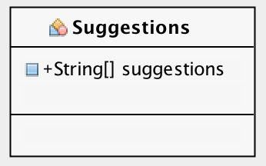

Conditions Class

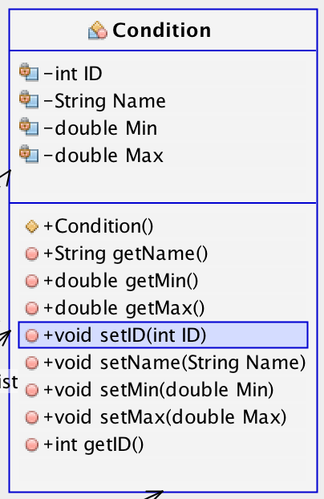

Sound Class

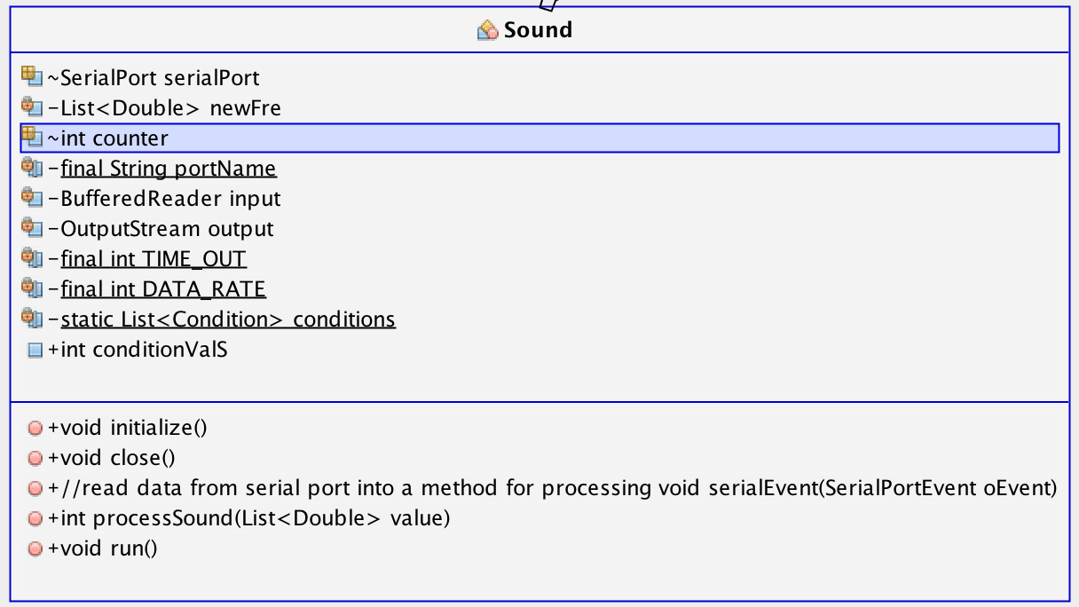

Read Condition Class

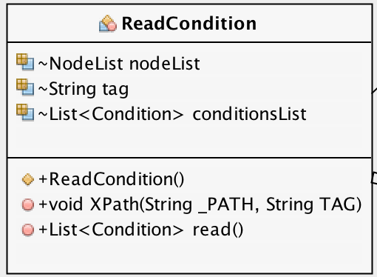

Accelerometer Error Handler Class

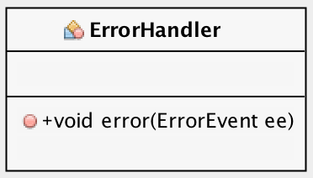

Manager Class

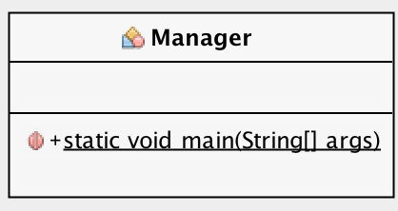

Motion Class

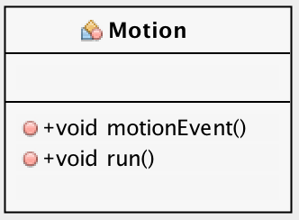

Notification Class

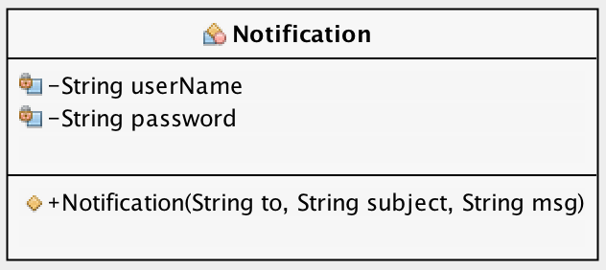

Accelerometer Attach Class

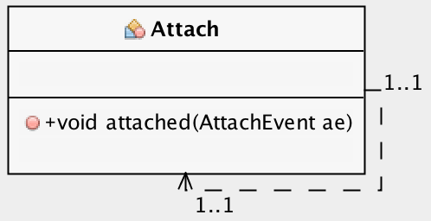

Accelerometer Data Listener

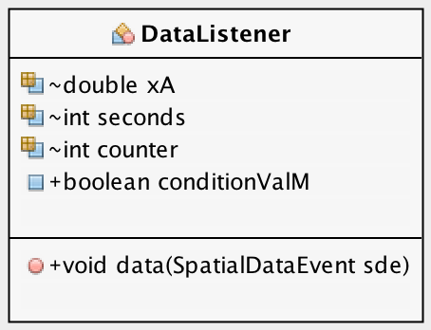

Appendix b – Gantt charts

Gantt Chart

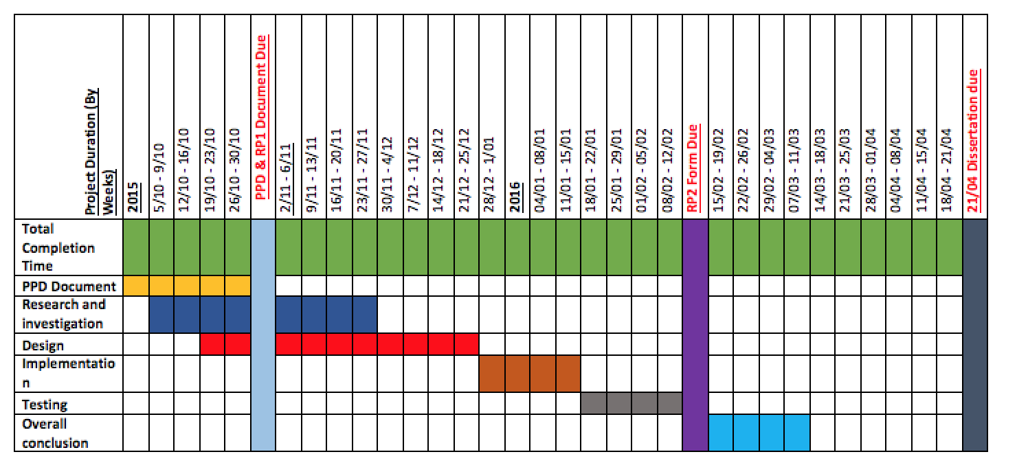

Updated Gantt chart

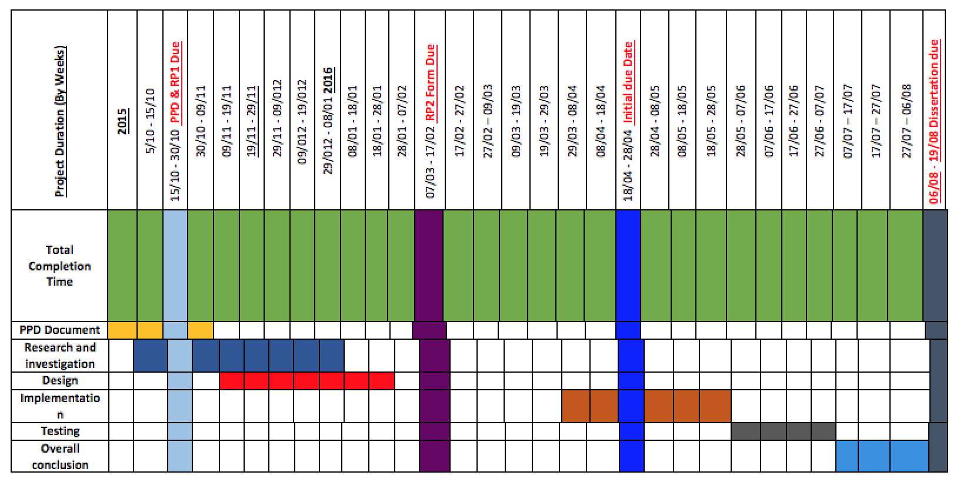

Appendix c – Project planning document

**Introduction**

Since the beginning of humanity, parenting for new born babies has been very difficult for some parents, especially with your first born if you have not had much experience with new-borns.

As new born babies cannot converse with their carers to let them know their needs or requirements they often result to crying which is a late indication of a want or need for a baby, they also have not yet developed a sense of non-verbal communication with their parent/carer, which makes baby parenting just that extra bit harder.

In my investigations, I have looked at ways technology has already been used to be able to make parenting for babies more simple/effective. Looking at baby radio/video monitors, I believe I have found a gap where I feel there is lack of intelligence to have more effective results in most of these products.

To tackle some of the core issues with baby parenting that I have researched about, I have developed an idea using the information I have acquired from these reviews and forums I have found online. I have found that there are various ways of how carers can tell when their baby may want or need something, however not all of these signs are early or active for the baby but usually late, which in some cases cannot be healthy for the baby and can be a root of causing issues with baby parenting.

For my project I will be using technology to be able to analyse behaviour and body readings of a baby using sensors, creating a smart environment. Using this information, I will query the results I receive from these sensors to be able to get accurate as possible suggestions of action for the baby which will be relayed to the cares mobile device using a mobile app through the WI-FI.

Focusing on the behaviours and body readings that baby’s give in conjunction with the various ways of that carers can tell when their baby wants or needs something, I will be able to produce a more effective and simplified methods to make the job for baby carers hopefully a lot more easier.

**Aims & Objectives**

The purpose of this project is to be able to make a more effective and simplified way for parents to take care of babies using technology. Individually the product will be able to carry out several individual functionalities to be able to accomplish these end results. All the individual functionalities that the product will be able to perform are stated below.

* The product will be able to accurately perform behaviour analysis on babies. **-** This will include noise detection to record when the baby is crying and will be measured in decibels, reading of body temperature to know if they are at an appropriate temperature, check for movement with a motion detector to be able to distinctively tell and record when the baby is sleeping, connect sensor to monitor and record ligament movement to monitor and record when and how frequently the baby is putting things in or near their mouth which could be indications of hunger.
* The product will be able to accurately read body readings of a baby. **-** This will include reading of body temperature to know if the baby’s temperature is at an appropriate temperature reading. The product will also be able to read the weight of the baby using a digital scale.
* The product will be able to use the results given from the behaviour analysis readings and the body readings to be able to produce accurate queried suggestions or suggestions of action for a baby.
* The product will be able to relay the suggestion or suggestion of action information to a mobile device instantly for carer. - This will be accomplished using a machine as a server where the sensors will send the information they acquire and will also be queried at this point, a mobile application on a mobile device where the carer will view this information which will sent over a local WI-FI network.
* The product will be able to record a baby’s behaviour pattern. – This will be to be able to predict the baby’s events and suggestions and also to be able to let the carer know when there is a change or difference in the baby’s behaviour.
* Product may have safety precautions on the entrance/exit of the smart environment(pressure sensor).
* Product may be able to protect a baby from scratching their selves as well as monitor baby hand movements.

**Milestones, Main Task & Deliverables**

During this project there will be several milestones along the journey to make the project more measurable and easier to accomplish task’s. The first mile stone will be the most key aspect of a project which is research. Getting the required information from reliable sources is very key in this project as the entire project is built on top of its different areas of research.

Firstly I be researching into further depth on baby’s requirements and needs and how you can identify them and what any other common issues there are. I have already done some secondary research and found a lot of useful information on online forums and articles, However I will be contacting member of baby parenting groups to be able to have a talk with some carers of baby and ask them personally what kind of issues they have which could make their lives easier when it comes to taking care of their baby’s.

Following after this I will next be taking out further research on the existing technology already out there, this research will allow me to be aware of my competitors and their products functionalities. In addition to this I will also be researching on the available components I could use to produce my product, which will allow me to be able to put together a strong feasible design for my product and also to have a clearer view of what components I will exactly need and if they will have compatibility issues or not.

Finally for research I will be doing further primary research, however this time I will be conversing with the carers about how I think I may be able to tackle some of the issues they have presented to me with their baby caring experiences to see where there may be room for improvement or if I my designs have are not up to requirements and this will also help to define the scope of the projects as I will be able to make more of an accurate age appropriate assumption and how effective the product may be for different ages.

Another core aspect of the project will be the development stage, the development stage would also have several milestones in it. As the development stage branches from the research stage, the first hurdle to tackle would be to be able to identify what hardware components the product would need to be assembled.

In conjunction with this, software will have to be developed to be able to control each of the hardware components used(sensor’s). This is key as smart and effective software development will help the product to run smoothly with as fast as possible with no errors.

The next task will be to create a software that will be able to run all the separate hardware’s software and allow communication between them. Over a server, where the queries for the results the hardware give will be carried out and information will be sent across.

The final functional requirement will be developed last which will be a mobile application which will be supported on a mobiles device which will receive suggestions and suggestions of action through the server.

The last mile stone in the development stage will end in testing the end product as a whole, to ensure that all the requirements are fully functional and the end results are as expected as the specification states.

In addition to this, not only hardware can have compatibility issues, but this can also occur on the software side as I will need to be aware of the differences in programming languages that some hardware components may be restricted to and also using their relevant development kits, but at the same time trying to limit the number of languages and development kits used to ensure consistency and make maintenance less complicated. This all falls under the outside scope of this project, but however this is an essential part to the project as the information produced from the hardware in key to the product.

However, during testing there may have an out of scope requirement, as to fully test the end product to its maximum potential a new born baby must be present. However due to resources and safety precautions this may be very unlikely that it will be possible, but the theory of the testing are very much possible I believe.

**Source of Information & Resources Required**

The resources I will use to help structure my project will come from several different sources, some of these specific sources will allow me to acquire relevant information needed. I will be using NTU Library, Google search, Google Scholar. From these resources I will obtain more information on babies behaviours and needs and requirements, as well as finding similar existing products. This will allow me to distinctively see where the gap in the market specifically is and exactly how my product exceeds existing products.

In addition to this I will also further exhaust the use of Google search to be able to locate baby parenting groups to be able to possibly have group discussions or just to converse with then to get their real life issues they find in baby parenting. This will also mean I have found an actual stakeholder/client and will be more credible as primary research.

For the hardware components that will be used to build this product I will be researching from Google search and “[https://www.cooking-hacks.com/](https://www.cooking-hacks.com/" \t "_blank)”, “[https://www.sparkfun.com/categories/135](https://www.sparkfun.com/categories/135" \t "_blank)” and “[http://www.phidgets.com/](http://www.phidgets.com/" \t "_blank)”. This will allow me to be prepared for what languages and development kits I will be using to produce this product.

**Project Risk**

Getting wrong or inaccurate information, this can cause your project to fail because your whole project will be built of invalid or unreliable information’s. To reduce the chances of tis happening it will be beneficial and more accurate if the information used came from a reliable source and is documented and referred to in reference. You could also go off and conduct your own primary research. These methods will also make your research a lot more credible.

I another risk could be lack of software quality development for the product which could cause effects in different ways. This could dramatically effect a project as lack of optimization could make the processes of the product run slow or not as fast as anticipated. In a worst case scenario it could result in system failure as the products not functioning properly may be due to software breaking. I will overcome this issue by using and following principles from a book called “Clean Code” to make sure the software developments are clean and working to the required standard with a high quality.

One of the biggest risk there could be which could have an great impact on the project is underestimation of the development, as sometimes unanticipated events may arise which can either set the project back by a significant amount of time which is unaffordable and in a further case if this hurdle is not overcame it can cause the product to become non-functional therefore it will not be even testable, which results in project failure. However these issues usually stem from lack of research and poor design, to overcome these types of issues thorough research must be conducted especially through the design stage. In some cases there may not be enough time before a deadline so contingency plans may have to be prepared to be able to be ready for these types of situations. This can result in sacrificing parts of the project to ensure the project is a complete package by the end of the deadline, bearing in mind this will not be possible with functional requirements as this will result in the specification requirements not being met.

**PSEL Issues**

**Professional issues**

It would be ethical to the messages that are sent to the carer of the baby to be formally written in a very clear and polite manor, as the product can only suggest not tell the carer what they must do. I believe this will help uphold the professionalism of the product as it designed to assist to make better not to take control.

**Social issues**

A social issue that my product may face is that as this information the product generates will be sent to the carers mobile device. As these days mobile devises have a huge usage rate of social activities where you can receive numerous notifications from different sources. To avoid chances of the carer being oblivious to the products notification a distinctive unique notification alarm will be used which continuously repeats until the notification has been attended to.

**Ethical issues**

I do not believe my project will have any ethical hurdles as I will not be working directly with baby’s, but I will be retrieving information from carers of the baby’s which will be of an appropriate age to give their own consent for me to use the relevant information they have provided me with to carry out my project which does not require any personal data what so ever.

**Legal issues**

Even though there will be no personal data used or collected, Just to be on the safe side the information that will be extracted from the sensors may have encryption security when being stored. In addition to this when information is no longer used or needed it will be deleted off the system. This will ensure that the data protection act is enforced and will also free irrelevant used memory to help maintain the consistency and speed of the product.

Appendix D – UML classes

Table (Arduino Micro Controllers)

|  |  |  |  |
| --- | --- | --- | --- |
| **UNO** | **MEGA** | **Lilly pad** | **Nano** |
|  |  |  |  |
| **Analogue** **Input**: 6  **PWM** **I/O**: 6  **Digital I/O**: 14  **Size**: 68.6mm x 53.3mm  **Voltage**: 5V | **Analogue Input**: 16  **PWM I/O**: 14  **Digital I/O**: 54  **Size**: 101.6mm x 53.3mm  **Voltage**: 5V | **Analogue** **Input**: 6  **PWM I/O**: 6  **Digital I/O**: 14  **Size**: 50mm  **Voltage**: 3.3V | **Analogue Input**: 8  **PWM I/O**: 6  **Digital I/O**: 14  **Size**: 43mm x 18mm  **Voltage**: 5V |
| The UNO board is the most commonly known board as this is this is the most recommended board for beginners and general purpose. | The MEGA board is an enhanced version of the UNO board giving more I/O capabilities and more processing power. | The Lilly pad has the same capabilities and processing power to the UNO board, however it is a lot smaller and designed with flexibility for wearable purposes. | The Nano board has the same functionality as the UNO board but in a different packaging. It uses its micro USB port to rely on power and to connect. |